False confession project

knitr::opts_chunk$set(echo = TRUE)  
knitr::opts_chunk$set(fig.height = 8, fig.width = 8)

## R Markdown

setwd("C://Users//joshj//My Drive//RESEARCH//LAB STUFF//Maddie Anna project//Results")   
  
library(readxl)  
d<-read_excel("false_confession.xlsx")  
########################  
  
  
library(dplyr)

##   
## Attaching package: 'dplyr'

## The following objects are masked from 'package:stats':  
##   
## filter, lag

## The following objects are masked from 'package:base':  
##   
## intersect, setdiff, setequal, union

d <- d %>% mutate(race.recoded=recode(race, "1" = "AI_AN",  
 "2" = "Asian",   
 "3"="Black",   
 "4" = "Hispanic",   
 "5" = "Middle_Eastern",   
 "7" = "White",   
 "6"= "NH_PI",  
 "8" = "Multi",  
 "1,2" = "Multi",  
 "1,3" = "Multi",  
 "1,4" = "Multi",  
 "1,5" = "Multi",  
 "1,6" = "Multi",  
 "1,7" = "Multi",  
 "1,2,4,7" = "Multi",  
 "1,3,4,7" = "Multi",  
 "1,4,7" = "Multi",  
 "2,4" = "Multi",  
 "2,3,7" = "Multi",  
 "2,7" = "Multi",  
 "7, 8" = "Multi",  
 "4,8" = "Multi",  
 "7,8" = "Multi",  
 "3,7" = "Multi",  
 "3,4" = "Multi",  
 "4,7" = "Multi",  
 "1,2,3,5,7" = "Multi",  
 "1,2,7" = "Multi",  
 "1,3,7" = "Multi",  
 "1,3,4" = "Multi",  
 "1,3,7" = "Multi",  
 "1,3,5,7" = "Multi",  
 "2,3" = "Multi",  
 "2,6" = "Multi",  
 "3,4,7" = "Multi",  
 "3,5,7" = "Multi",  
 "3,6" = "Multi",  
 "4,5,7" = "Multi",  
 "5,7" = "Multi"))  
  
d <- d %>% mutate(race.recoded=recode(race.recoded, "Multi" = "Multi/Other"))  
  
  
  
d<- d %>% mutate_at(c("race.recoded", "id", "sex",   
 "lm_q1", "lm_q2"), as.factor)  
  
d <- d %>% mutate(sex=recode(sex, `1` = "Male", `2` = "Female"))  
  
  
##############################  
  
#participants before attention/manipulation check failure removals   
mean(d$age)

## [1] 37.82587

sd(d$age)

## [1] 11.86906

table(d$sex)

##   
## Male Female   
## 91 110

prop.table(table(d$sex))*100

##   
## Male Female   
## 45.27363 54.72637

table(d$race.recoded)

##   
## Asian Black Hispanic Multi/Other White   
## 6 40 8 17 130

round(prop.table(table(d$race.recoded))*100, 2)

##   
## Asian Black Hispanic Multi/Other White   
## 2.99 19.90 3.98 8.46 64.68

#############  
  
table(d$check_1_means_passed)

##   
## 0 1   
## 16 185

(16/185)*100

## [1] 8.648649

#8.5% failed at least one of the checks   
  
  
d<-d %>% filter(check_1_means_passed=="1")  
table(d$check_1_means_passed)

##   
## 1   
## 185

table(d$Q_RecaptchaScore <.5) #2 scores but nothing unusual about them in terms of how long they took

##   
## FALSE TRUE   
## 183 2

#they also passed both checks. Probably false positives   
#############  
  
d$interaction_term <- as.numeric(d$juv) * as.numeric(d$dis)  
  
  
  
d <- d %>% mutate(juv.recode=recode(juv, '0'="Adult", '1'="Juvenille"))  
d <- d %>% mutate(dis.recode=recode(dis, '0'="Average Intelligence", '1'="Disability"))  
  
  
d$interaction_term2 <- interaction(as.factor(d$juv.recode), as.factor(d$dis.recode))  
  
#plots for description only   
library(ggplot2)  
box1<-ggplot(aes(y = guilt, x = as.factor(interaction_term2)), data = d) +   
 geom_boxplot(aes(fill=as.factor(interaction_term2)), show.legend = FALSE) + theme_minimal()  
  
box1

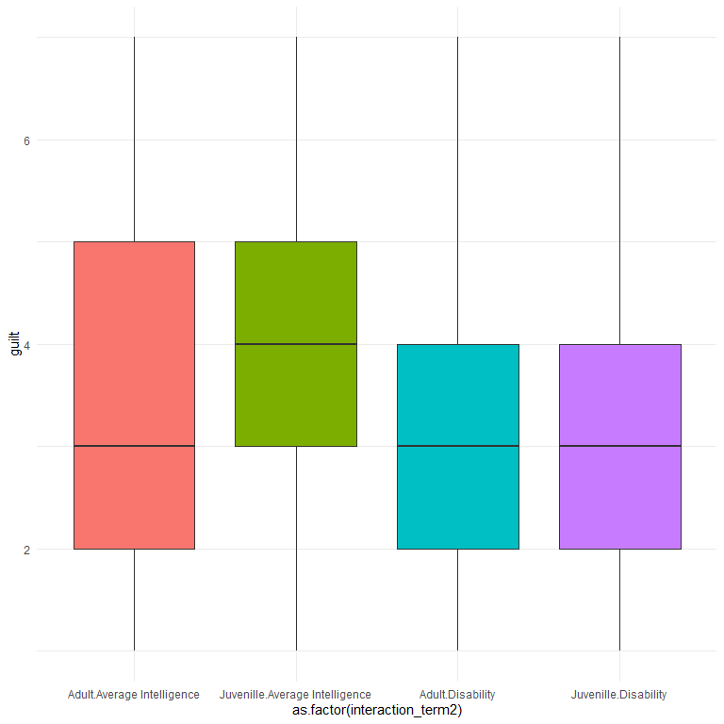

library(ggplot2)  
box1<-ggplot(aes(y = perc, x = as.factor(interaction_term2)), data = d) +   
 geom_boxplot(aes(fill=as.factor(interaction_term2)), show.legend = FALSE) + theme_minimal()  
  
box1

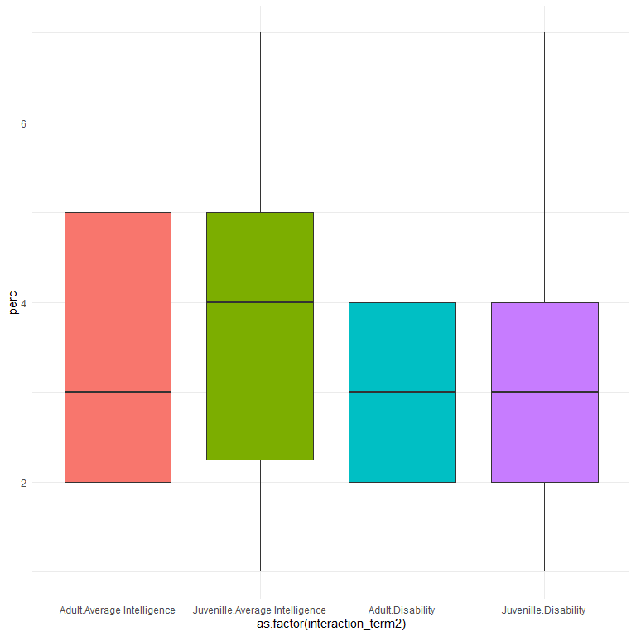

########################  
#examining the effects of the two conditions with ANOVA  
  
library(jmv)   
  
ANOVA(formula = perc~juv.recode + dis.recode, data = d, emMeans = ~ juv.recode + dis.recode,   
 emmPlots = TRUE, effectSize="omega")

##   
## ANOVA  
##   
## ANOVA - perc   
## ──────────────────────────────────────────────────────────────────────────────────────────────   
## Sum of Squares df Mean Square F p ω²   
## ──────────────────────────────────────────────────────────────────────────────────────────────   
## juv.recode 0.8128690 1 0.8128690 0.3261505 0.5686392 -0.0035238   
## dis.recode 19.6919563 1 19.6919563 7.9010787 0.0054817 0.0360884   
## Residuals 453.6008556 182 2.4923124   
## ──────────────────────────────────────────────────────────────────────────────────────────────

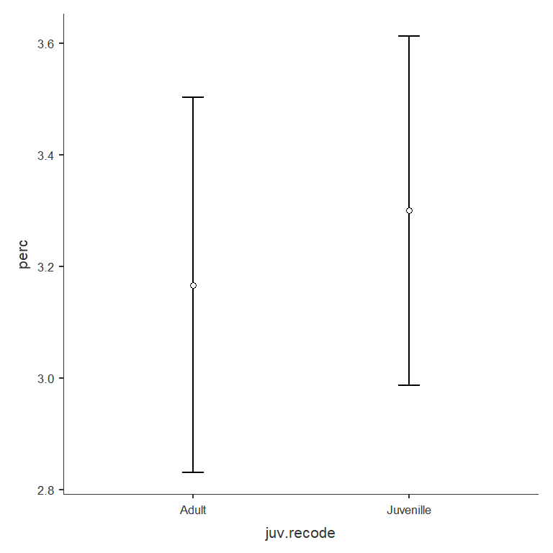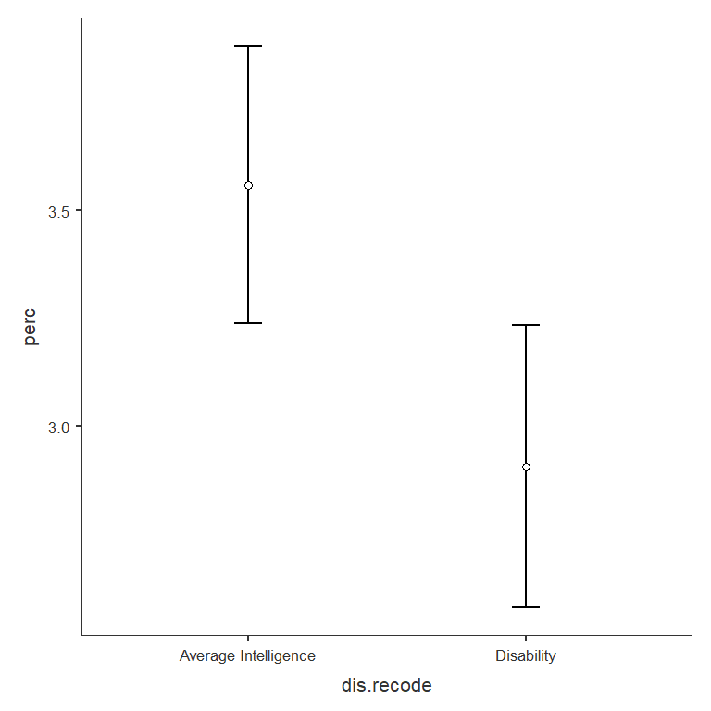

#clearly no effect of juv but there is an effect of dis --> those who read a condition where the individual was intellectually disabled....  
#.... perceived the credibility of the confession lower than the condition where the person was described as average intelligence   
  
ANOVA(formula = perc~juv.recode * dis.recode, data = d, emMeans = ~ juv.recode:dis.recode,   
 emmPlots = TRUE, effectSize="omega")

##   
## ANOVA  
##   
## ANOVA - perc   
## ─────────────────────────────────────────────────────────────────────────────────────────────────────────   
## Sum of Squares df Mean Square F p ω²   
## ─────────────────────────────────────────────────────────────────────────────────────────────────────────   
## juv.recode 0.7972300 1 0.7972300 0.3182940 0.5733331 -0.0035857   
## dis.recode 19.2829179 1 19.2829179 7.6987025 0.0061060 0.0352346   
## juv.recode:dis.recode 0.2506762 1 0.2506762 0.1000825 0.7520953 -0.0047335   
## Residuals 453.3501793 181 2.5046971   
## ─────────────────────────────────────────────────────────────────────────────────────────────────────────

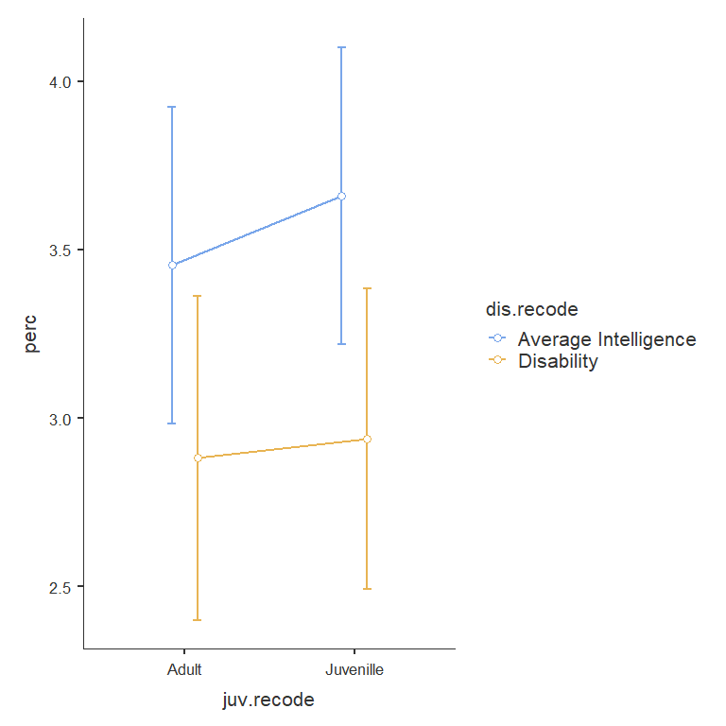

#No evidence of the interaction   
  
  
######

#############  
#examining the effects of the two conditions with regression   
mod1<-lm(perc~juv + dis, data=d)  
summary(mod1)

##   
## Call:  
## lm(formula = perc ~ juv + dis, data = d)  
##   
## Residuals:  
## Min 1Q Median 3Q Max   
## -2.6260 -0.9734 0.0266 1.1595 4.0266   
##   
## Coefficients:  
## Estimate Std. Error t value Pr(>|t|)   
## (Intercept) 3.4931 0.2045 17.078 < 2e-16 ***  
## juv 0.1329 0.2327 0.571 0.56864   
## dis -0.6526 0.2322 -2.811 0.00548 **   
## ---  
## Signif. codes: 0 '***' 0.001 '**' 0.01 '*' 0.05 '.' 0.1 ' ' 1  
##   
## Residual standard error: 1.579 on 182 degrees of freedom  
## Multiple R-squared: 0.04315, Adjusted R-squared: 0.03263   
## F-statistic: 4.103 on 2 and 182 DF, p-value: 0.01807

#effect of dis but not juv  
  
mod2<-lm(perc~juv * dis, data=d)  
summary(mod2)

##   
## Call:  
## lm(formula = perc ~ juv * dis, data = d)  
##   
## Residuals:  
## Min 1Q Median 3Q Max   
## -2.6600 -0.9388 0.0612 1.1190 4.0612   
##   
## Coefficients:  
## Estimate Std. Error t value Pr(>|t|)   
## (Intercept) 3.4545 0.2386 14.479 <2e-16 ***  
## juv 0.2055 0.3271 0.628 0.5308   
## dis -0.5736 0.3414 -1.680 0.0947 .   
## juv:dis -0.1476 0.4667 -0.316 0.7521   
## ---  
## Signif. codes: 0 '***' 0.001 '**' 0.01 '*' 0.05 '.' 0.1 ' ' 1  
##   
## Residual standard error: 1.583 on 181 degrees of freedom  
## Multiple R-squared: 0.04367, Adjusted R-squared: 0.02782   
## F-statistic: 2.755 on 3 and 181 DF, p-value: 0.04389

#no interaction. The effect of dis is changing slightly   
#it looks like what is happening here is that when including the interaction term, that is masking some of the effect of dis  
#that appears to be due to the fact the juveniles actually tended to have higher perceived credibility in their confessions   
#because the dis effect is negative and the juv effect is positive, the interaction term is suppressing that effect  
#to deal with that issue, in the code below, the coding for juv is reversed, so that 1 will mean adult, and 0 will mean juvenile   
  
library(AICcmodavg)  
modlist<- list(mod1, mod2)  
aictab(cand.set = modlist)

## Warning in aictab.AIClm(cand.set = modlist):   
## Model names have been supplied automatically in the table

##   
## Model selection based on AICc:  
##   
## K AICc Delta_AICc AICcWt Cum.Wt LL  
## Mod1 4 699.15 0.00 0.73 0.73 -345.46  
## Mod2 5 701.16 2.01 0.27 1.00 -345.41

bictab(cand.set = modlist)

## Warning in bictab.AIClm(cand.set = modlist):   
## Model names have been supplied automatically in the table

##   
## Model selection based on BIC:  
##   
## K BIC Delta_BIC BICWt Cum.Wt LL  
## Mod1 4 711.81 0.00 0.93 0.93 -345.46  
## Mod2 5 716.93 5.12 0.07 1.00 -345.41

#no evidence the interaction is adding anything in terms of prediction

##################  
d <- d %>% mutate(juv.rev=recode(juv, `0` = "1", `1` = "0"))  
  
d$interaction_term.r <- as.numeric(d$juv.rev) * as.numeric(d$dis)

##################  
  
library(lavaan)

## This is lavaan 0.6-19  
## lavaan is FREE software! Please report any bugs.

##   
## Attaching package: 'lavaan'

## The following objects are masked from 'package:jmv':  
##   
## cfa, efa

# Specify the model  
model1 <- '  
 # Mediation part  
 perc ~ a1*juv.rev + a2*dis + a3*interaction_term.r   
 guilt ~ b1*perc + c1*juv.rev + c2*dis + c3*interaction_term.r   
   
 # Indirect effect  
 indirect_juv := a1 * b1 # Indirect effect of juv through perc  
 indirect_dis := a2 * b1 # Indirect effect of dis through perc  
 indirect_int := a3 * b1 # Indirect effect of the interaction term through perc  
   
 # Direct effects (from juv, dis, interaction to guilt)  
 direct_juv := c1 # Direct effect of juv on guilt  
 direct_dis := c2 # Direct effect of dis on guilt  
 direct_int := c3 # Direct effect of interaction on guilt  
   
 # Total effects  
 total_juv := direct_juv + indirect_juv # Total effect of juv on guilt  
 total_dis := direct_dis + indirect_dis # Total effect of dis on guilt  
 total_int := direct_int + indirect_int # Total effect of the interaction on guilt  
'  
  
# Fit the model using the lavaan function  
fit1 <- sem(model1, data = d)  
  
  
# Display a summary of the results  
summary(fit1)

## lavaan 0.6-19 ended normally after 1 iteration  
##   
## Estimator ML  
## Optimization method NLMINB  
## Number of model parameters 9  
##   
## Number of observations 185  
##   
## Model Test User Model:  
##   
## Test statistic 0.000  
## Degrees of freedom 0  
##   
## Parameter Estimates:  
##   
## Standard errors Standard  
## Information Expected  
## Information saturated (h1) model Structured  
##   
## Regressions:  
## Estimate Std.Err z-value P(>|z|)  
## perc ~   
## juv.rev (a1) -0.205 0.324 -0.635 0.525  
## dis (a2) -0.721 0.315 -2.292 0.022  
## intrctn_. (a3) 0.148 0.462 0.320 0.749  
## guilt ~   
## perc (b1) 0.671 0.055 12.106 0.000  
## juv.rev (c1) 0.145 0.244 0.594 0.552  
## dis (c2) 0.009 0.241 0.037 0.971  
## intrctn_. (c3) -0.399 0.348 -1.146 0.252  
##   
## Variances:  
## Estimate Std.Err z-value P(>|z|)  
## .perc 2.451 0.255 9.618 0.000  
## .guilt 1.393 0.145 9.618 0.000  
##   
## Defined Parameters:  
## Estimate Std.Err z-value P(>|z|)  
## indirect_juv -0.138 0.217 -0.634 0.526  
## indirect_dis -0.484 0.215 -2.252 0.024  
## indirect_int 0.099 0.310 0.320 0.749  
## direct_juv 0.145 0.244 0.594 0.552  
## direct_dis 0.009 0.241 0.037 0.971  
## direct_int -0.399 0.348 -1.146 0.252  
## total_juv 0.007 0.327 0.022 0.982  
## total_dis -0.475 0.318 -1.496 0.135  
## total_int -0.300 0.466 -0.644 0.520

summary(fit1, standardized = TRUE, fit.measures = TRUE)

## lavaan 0.6-19 ended normally after 1 iteration  
##   
## Estimator ML  
## Optimization method NLMINB  
## Number of model parameters 9  
##   
## Number of observations 185  
##   
## Model Test User Model:  
##   
## Test statistic 0.000  
## Degrees of freedom 0  
##   
## Model Test Baseline Model:  
##   
## Test statistic 123.783  
## Degrees of freedom 7  
## P-value 0.000  
##   
## User Model versus Baseline Model:  
##   
## Comparative Fit Index (CFI) 1.000  
## Tucker-Lewis Index (TLI) 1.000  
##   
## Loglikelihood and Information Criteria:  
##   
## Loglikelihood user model (H0) -638.562  
## Loglikelihood unrestricted model (H1) NA  
##   
## Akaike (AIC) 1295.123  
## Bayesian (BIC) 1324.107  
## Sample-size adjusted Bayesian (SABIC) 1295.601  
##   
## Root Mean Square Error of Approximation:  
##   
## RMSEA 0.000  
## 90 Percent confidence interval - lower 0.000  
## 90 Percent confidence interval - upper 0.000  
## P-value H_0: RMSEA <= 0.050 NA  
## P-value H_0: RMSEA >= 0.080 NA  
##   
## Standardized Root Mean Square Residual:  
##   
## SRMR 0.000  
##   
## Parameter Estimates:  
##   
## Standard errors Standard  
## Information Expected  
## Information saturated (h1) model Structured  
##   
## Regressions:  
## Estimate Std.Err z-value P(>|z|) Std.lv Std.all  
## perc ~   
## juv.rev (a1) -0.205 0.324 -0.635 0.525 -0.205 -0.064  
## dis (a2) -0.721 0.315 -2.292 0.022 -0.721 -0.225  
## intrctn_. (a3) 0.148 0.462 0.320 0.749 0.148 0.039  
## guilt ~   
## perc (b1) 0.671 0.055 12.106 0.000 0.671 0.666  
## juv.rev (c1) 0.145 0.244 0.594 0.552 0.145 0.045  
## dis (c2) 0.009 0.241 0.037 0.971 0.009 0.003  
## intrctn_. (c3) -0.399 0.348 -1.146 0.252 -0.399 -0.104  
##   
## Variances:  
## Estimate Std.Err z-value P(>|z|) Std.lv Std.all  
## .perc 2.451 0.255 9.618 0.000 2.451 0.956  
## .guilt 1.393 0.145 9.618 0.000 1.393 0.536  
##   
## Defined Parameters:  
## Estimate Std.Err z-value P(>|z|) Std.lv Std.all  
## indirect_juv -0.138 0.217 -0.634 0.526 -0.138 -0.043  
## indirect_dis -0.484 0.215 -2.252 0.024 -0.484 -0.150  
## indirect_int 0.099 0.310 0.320 0.749 0.099 0.026  
## direct_juv 0.145 0.244 0.594 0.552 0.145 0.045  
## direct_dis 0.009 0.241 0.037 0.971 0.009 0.003  
## direct_int -0.399 0.348 -1.146 0.252 -0.399 -0.104  
## total_juv 0.007 0.327 0.022 0.982 0.007 0.002  
## total_dis -0.475 0.318 -1.496 0.135 -0.475 -0.147  
## total_int -0.300 0.466 -0.644 0.520 -0.300 -0.078

# To view the estimates for indirect, direct, and total effects  
parameterEstimates(fit1, ci = TRUE, standardized = TRUE)

## lhs op rhs label est se  
## 1 perc ~ juv.rev a1 -0.205 0.324  
## 2 perc ~ dis a2 -0.721 0.315  
## 3 perc ~ interaction_term.r a3 0.148 0.462  
## 4 guilt ~ perc b1 0.671 0.055  
## 5 guilt ~ juv.rev c1 0.145 0.244  
## 6 guilt ~ dis c2 0.009 0.241  
## 7 guilt ~ interaction_term.r c3 -0.399 0.348  
## 8 perc ~~ perc 2.451 0.255  
## 9 guilt ~~ guilt 1.393 0.145  
## 10 juv.rev ~~ juv.rev 0.249 0.000  
## 11 juv.rev ~~ dis -0.002 0.000  
## 12 juv.rev ~~ interaction_term.r 0.121 0.000  
## 13 dis ~~ dis 0.250 0.000  
## 14 dis ~~ interaction_term.r 0.115 0.000  
## 15 interaction_term.r ~~ interaction_term.r 0.175 0.000  
## 16 indirect_juv := a1*b1 indirect_juv -0.138 0.217  
## 17 indirect_dis := a2*b1 indirect_dis -0.484 0.215  
## 18 indirect_int := a3*b1 indirect_int 0.099 0.310  
## 19 direct_juv := c1 direct_juv 0.145 0.244  
## 20 direct_dis := c2 direct_dis 0.009 0.241  
## 21 direct_int := c3 direct_int -0.399 0.348  
## 22 total_juv := direct_juv+indirect_juv total_juv 0.007 0.327  
## 23 total_dis := direct_dis+indirect_dis total_dis -0.475 0.318  
## 24 total_int := direct_int+indirect_int total_int -0.300 0.466  
## z pvalue ci.lower ci.upper std.lv std.all std.nox  
## 1 -0.635 0.525 -0.840 0.429 -0.205 -0.064 -0.128  
## 2 -2.292 0.022 -1.338 -0.104 -0.721 -0.225 -0.451  
## 3 0.320 0.749 -0.757 1.052 0.148 0.039 0.092  
## 4 12.106 0.000 0.562 0.780 0.671 0.666 0.666  
## 5 0.594 0.552 -0.334 0.624 0.145 0.045 0.090  
## 6 0.037 0.971 -0.463 0.480 0.009 0.003 0.005  
## 7 -1.146 0.252 -1.081 0.283 -0.399 -0.104 -0.247  
## 8 9.618 0.000 1.951 2.950 2.451 0.956 0.956  
## 9 9.618 0.000 1.109 1.677 1.393 0.536 0.536  
## 10 NA NA 0.249 0.249 0.249 1.000 0.249  
## 11 NA NA -0.002 -0.002 -0.002 -0.007 -0.002  
## 12 NA NA 0.121 0.121 0.121 0.581 0.121  
## 13 NA NA 0.250 0.250 0.250 1.000 0.250  
## 14 NA NA 0.115 0.115 0.115 0.551 0.115  
## 15 NA NA 0.175 0.175 0.175 1.000 0.175  
## 16 -0.634 0.526 -0.564 0.288 -0.138 -0.043 -0.085  
## 17 -2.252 0.024 -0.905 -0.063 -0.484 -0.150 -0.300  
## 18 0.320 0.749 -0.508 0.706 0.099 0.026 0.061  
## 19 0.594 0.552 -0.334 0.624 0.145 0.045 0.090  
## 20 0.037 0.971 -0.463 0.480 0.009 0.003 0.005  
## 21 -1.146 0.252 -1.081 0.283 -0.399 -0.104 -0.247  
## 22 0.022 0.982 -0.633 0.647 0.007 0.002 0.005  
## 23 -1.496 0.135 -1.098 0.147 -0.475 -0.147 -0.295  
## 24 -0.644 0.520 -1.213 0.613 -0.300 -0.078 -0.186

parameterEstimates(fit1, boot.ci.type = "bca.simple")

## lhs op rhs label est se  
## 1 perc ~ juv.rev a1 -0.205 0.324  
## 2 perc ~ dis a2 -0.721 0.315  
## 3 perc ~ interaction_term.r a3 0.148 0.462  
## 4 guilt ~ perc b1 0.671 0.055  
## 5 guilt ~ juv.rev c1 0.145 0.244  
## 6 guilt ~ dis c2 0.009 0.241  
## 7 guilt ~ interaction_term.r c3 -0.399 0.348  
## 8 perc ~~ perc 2.451 0.255  
## 9 guilt ~~ guilt 1.393 0.145  
## 10 juv.rev ~~ juv.rev 0.249 0.000  
## 11 juv.rev ~~ dis -0.002 0.000  
## 12 juv.rev ~~ interaction_term.r 0.121 0.000  
## 13 dis ~~ dis 0.250 0.000  
## 14 dis ~~ interaction_term.r 0.115 0.000  
## 15 interaction_term.r ~~ interaction_term.r 0.175 0.000  
## 16 indirect_juv := a1*b1 indirect_juv -0.138 0.217  
## 17 indirect_dis := a2*b1 indirect_dis -0.484 0.215  
## 18 indirect_int := a3*b1 indirect_int 0.099 0.310  
## 19 direct_juv := c1 direct_juv 0.145 0.244  
## 20 direct_dis := c2 direct_dis 0.009 0.241  
## 21 direct_int := c3 direct_int -0.399 0.348  
## 22 total_juv := direct_juv+indirect_juv total_juv 0.007 0.327  
## 23 total_dis := direct_dis+indirect_dis total_dis -0.475 0.318  
## 24 total_int := direct_int+indirect_int total_int -0.300 0.466  
## z pvalue ci.lower ci.upper  
## 1 -0.635 0.525 -0.840 0.429  
## 2 -2.292 0.022 -1.338 -0.104  
## 3 0.320 0.749 -0.757 1.052  
## 4 12.106 0.000 0.562 0.780  
## 5 0.594 0.552 -0.334 0.624  
## 6 0.037 0.971 -0.463 0.480  
## 7 -1.146 0.252 -1.081 0.283  
## 8 9.618 0.000 1.951 2.950  
## 9 9.618 0.000 1.109 1.677  
## 10 NA NA 0.249 0.249  
## 11 NA NA -0.002 -0.002  
## 12 NA NA 0.121 0.121  
## 13 NA NA 0.250 0.250  
## 14 NA NA 0.115 0.115  
## 15 NA NA 0.175 0.175  
## 16 -0.634 0.526 -0.564 0.288  
## 17 -2.252 0.024 -0.905 -0.063  
## 18 0.320 0.749 -0.508 0.706  
## 19 0.594 0.552 -0.334 0.624  
## 20 0.037 0.971 -0.463 0.480  
## 21 -1.146 0.252 -1.081 0.283  
## 22 0.022 0.982 -0.633 0.647  
## 23 -1.496 0.135 -1.098 0.147  
## 24 -0.644 0.520 -1.213 0.613

#plotting   
library(lavaanPlot)  
labels = list(guilt = "Guilty", perc = "Perceived Credibility", juv.rev= "Adult vs. Juvenille", dis="Average Intelligence vs. Intellectual Disability",  
 interaction_term.r="Juvenille x Intellectual Disability Interaction")  
  
lavaanPlot(model = fit1,   
 graph_options = list(layout = "circo"),  
 labels = labels,  
 node_options = list(shape = "box", fontname = "Helvetica"),  
 edge_options = list(color = "grey"), coefs = TRUE, stars="regress")

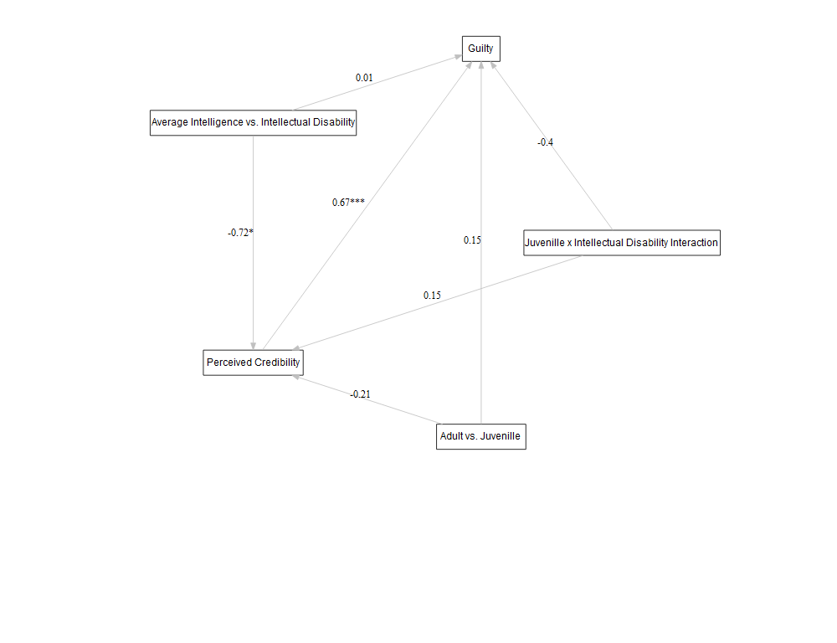

lavaanPlot(model = fit1,   
 graph_options = list(rankdir = "RL"),  
 labels = labels,  
 node_options = list(shape = "box", fontname = "Helvetica"),  
 edge_options = list(color = "grey"), coefs = TRUE, stars="regress")

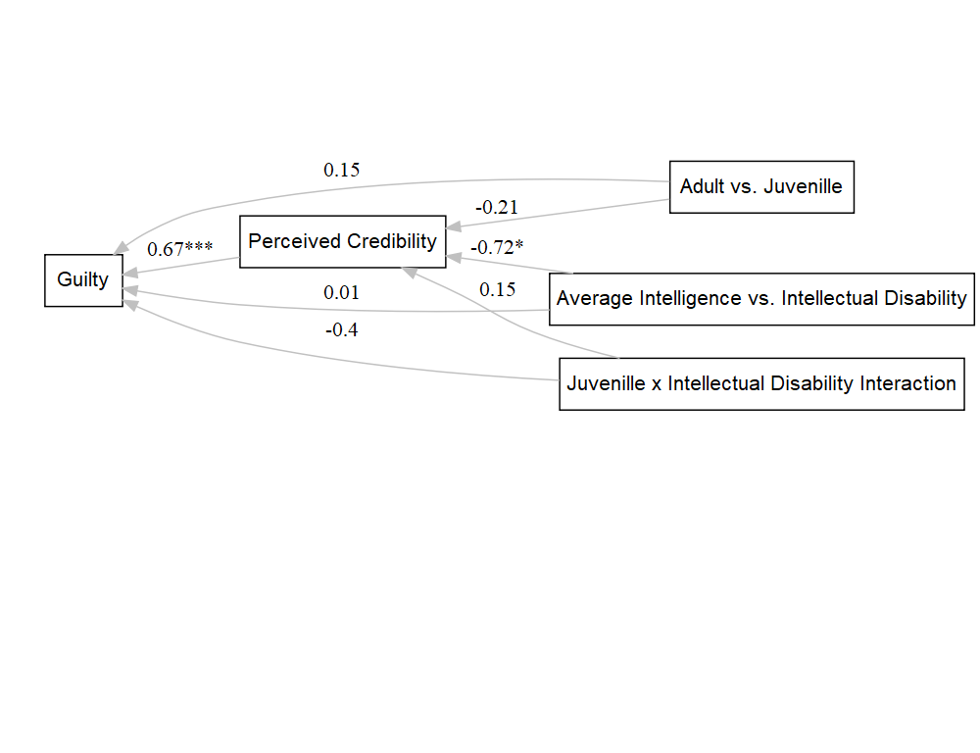

lavaanPlot(model = fit1,   
 graph_options = list(rankdir = "BT"),  
 labels = labels,  
 node_options = list(shape = "box", fontname = "Helvetica"),  
 edge_options = list(color = "grey"), coefs = TRUE, stars="regress")

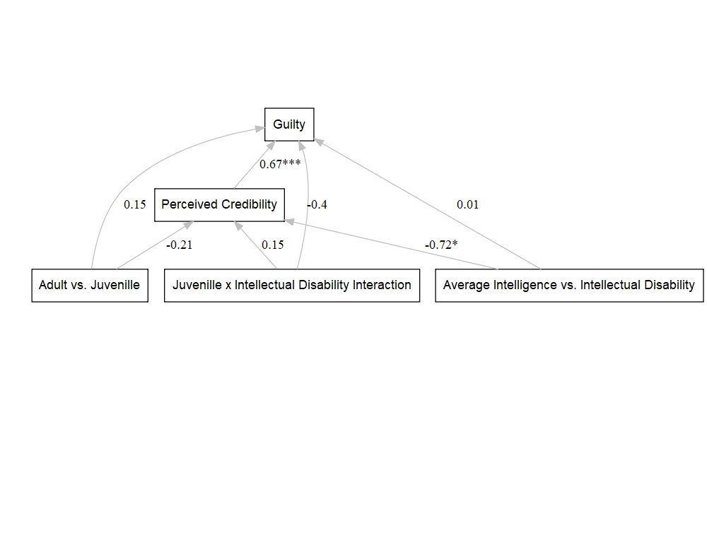

####################  
############################################  
table(d$guilt.dichot)

##   
## 0 1   
## 142 43

table(d$guilt)

##   
## 1 2 3 4 5 6 7   
## 20 42 40 35 29 9 10

library(polycor)  
polyserial(d$guilt, d$guilt.dichot)

## [1] 0.9533271

#very strong relationship between guilt which was a likert item and guilt.dichot which was dichotomous   
  
#looks like most people tended towards not guilty   
  
table(d$interaction_term2, d$guilt.dichot)

##   
## 0 1  
## Adult.Average Intelligence 30 14  
## Juvenille.Average Intelligence 34 16  
## Adult.Disability 34 8  
## Juvenille.Disability 44 5

##############  
library(lavaan)  
# Specify model  
model2 <- '  
 # Mediation part  
 perc ~ a1*juv.rev + a2*dis + a3*interaction_term.r   
 guilt.dichot ~ b1*perc + c1*juv.rev + c2*dis + c3*interaction_term.r   
   
 # Indirect effect  
 indirect_juv := a1 * b1 # Indirect effect of juv through perc  
 indirect_dis := a2 * b1 # Indirect effect of dis through perc  
 indirect_int := a3 * b1 # Indirect effect of the interaction term through perc  
   
 # Direct effects (from juv, dis, interaction to guilt)  
 direct_juv := c1 # Direct effect of juv on guilt  
 direct_dis := c2 # Direct effect of dis on guilt  
 direct_int := c3 # Direct effect of interaction on guilt  
   
 # Total effects  
 total_juv := direct_juv + indirect_juv # Total effect of juv on guilt  
 total_dis := direct_dis + indirect_dis # Total effect of dis on guilt  
 total_int := direct_int + indirect_int # Total effect of the interaction on guilt  
'  
  
  
# Fit the model using the lavaan function  
fit2 <- sem(model2, data = d, ordered = "guilt.dichot")  
summary(fit2)

## lavaan 0.6-19 ended normally after 51 iterations  
##   
## Estimator DWLS  
## Optimization method NLMINB  
## Number of model parameters 10  
##   
## Number of observations 185  
##   
## Model Test User Model:  
## Standard Scaled  
## Test Statistic 0.000 0.000  
## Degrees of freedom 0 0  
##   
## Parameter Estimates:  
##   
## Parameterization Delta  
## Standard errors Robust.sem  
## Information Expected  
## Information saturated (h1) model Unstructured  
##   
## Regressions:  
## Estimate Std.Err z-value P(>|z|)  
## perc ~   
## juv.rev (a1) -0.205 0.312 -0.658 0.510  
## dis (a2) -0.721 0.320 -2.255 0.024  
## intrctn_. (a3) 0.148 0.473 0.312 0.755  
## guilt.dichot ~   
## perc (b1) 0.409 0.034 12.149 0.000  
## juv.rev (c1) 0.079 0.235 0.336 0.737  
## dis (c2) -0.507 0.269 -1.886 0.059  
## intrctn_. (c3) 0.339 0.371 0.912 0.362  
##   
## Intercepts:  
## Estimate Std.Err z-value P(>|z|)  
## .perc 3.865 0.489 7.901 0.000  
##   
## Thresholds:  
## Estimate Std.Err z-value P(>|z|)  
## guilt.dicht|t1 2.045 0.380 5.382 0.000  
##   
## Variances:  
## Estimate Std.Err z-value P(>|z|)  
## .perc 2.451 0.337 7.274 0.000  
## .guilt.dichot 0.589   
##   
## Defined Parameters:  
## Estimate Std.Err z-value P(>|z|)  
## indirect_juv -0.084 0.128 -0.658 0.511  
## indirect_dis -0.295 0.132 -2.240 0.025  
## indirect_int 0.060 0.193 0.312 0.755  
## direct_juv 0.079 0.235 0.336 0.737  
## direct_dis -0.507 0.269 -1.886 0.059  
## direct_int 0.339 0.371 0.912 0.362  
## total_juv -0.005 0.270 -0.019 0.985  
## total_dis -0.802 0.306 -2.624 0.009  
## total_int 0.399 0.427 0.934 0.350

# view the estimates  
parameterEstimates(fit2, ci = TRUE, standardized = TRUE)

## lhs op rhs label est se  
## 1 perc ~ juv.rev a1 -0.205 0.312  
## 2 perc ~ dis a2 -0.721 0.320  
## 3 perc ~ interaction_term.r a3 0.148 0.473  
## 4 guilt.dichot ~ perc b1 0.409 0.034  
## 5 guilt.dichot ~ juv.rev c1 0.079 0.235  
## 6 guilt.dichot ~ dis c2 -0.507 0.269  
## 7 guilt.dichot ~ interaction_term.r c3 0.339 0.371  
## 8 guilt.dichot | t1 2.045 0.380  
## 9 perc ~~ perc 2.451 0.337  
## 10 guilt.dichot ~~ guilt.dichot 0.589 0.000  
## 11 juv.rev ~~ juv.rev 0.250 0.000  
## 12 juv.rev ~~ dis -0.002 0.000  
## 13 juv.rev ~~ interaction_term.r 0.122 0.000  
## 14 dis ~~ dis 0.251 0.000  
## 15 dis ~~ interaction_term.r 0.116 0.000  
## 16 interaction_term.r ~~ interaction_term.r 0.176 0.000  
## 17 guilt.dichot ~*~ guilt.dichot 1.000 0.000  
## 18 perc ~1 3.865 0.489  
## 19 guilt.dichot ~1 0.000 0.000  
## 20 juv.rev ~1 1.465 0.000  
## 21 dis ~1 0.492 0.000  
## 22 interaction_term.r ~1 0.227 0.000  
## 23 indirect_juv := a1*b1 indirect_juv -0.084 0.128  
## 24 indirect_dis := a2*b1 indirect_dis -0.295 0.132  
## 25 indirect_int := a3*b1 indirect_int 0.060 0.193  
## 26 direct_juv := c1 direct_juv 0.079 0.235  
## 27 direct_dis := c2 direct_dis -0.507 0.269  
## 28 direct_int := c3 direct_int 0.339 0.371  
## 29 total_juv := direct_juv+indirect_juv total_juv -0.005 0.270  
## 30 total_dis := direct_dis+indirect_dis total_dis -0.802 0.306  
## 31 total_int := direct_int+indirect_int total_int 0.399 0.427  
## z pvalue ci.lower ci.upper std.lv std.all std.nox  
## 1 -0.658 0.510 -0.817 0.406 -0.205 -0.064 -0.128  
## 2 -2.255 0.024 -1.348 -0.094 -0.721 -0.226 -0.450  
## 3 0.312 0.755 -0.779 1.074 0.148 0.039 0.092  
## 4 12.149 0.000 0.343 0.475 0.409 0.621 0.621  
## 5 0.336 0.737 -0.381 0.539 0.079 0.037 0.075  
## 6 -1.886 0.059 -1.034 0.020 -0.507 -0.241 -0.480  
## 7 0.912 0.362 -0.389 1.066 0.339 0.135 0.321  
## 8 5.382 0.000 1.300 2.789 2.045 1.936 1.936  
## 9 7.274 0.000 1.790 3.111 2.451 0.956 0.956  
## 10 NA NA 0.589 0.589 0.589 0.529 0.529  
## 11 NA NA 0.250 0.250 0.250 1.000 0.250  
## 12 NA NA -0.002 -0.002 -0.002 -0.007 -0.002  
## 13 NA NA 0.122 0.122 0.122 0.581 0.122  
## 14 NA NA 0.251 0.251 0.251 1.000 0.251  
## 15 NA NA 0.116 0.116 0.116 0.551 0.116  
## 16 NA NA 0.176 0.176 0.176 1.000 0.176  
## 17 NA NA 1.000 1.000 1.000 1.000 1.000  
## 18 7.901 0.000 2.907 4.824 3.865 2.414 2.414  
## 19 NA NA 0.000 0.000 0.000 0.000 0.000  
## 20 NA NA 1.465 1.465 1.465 2.929 1.465  
## 21 NA NA 0.492 0.492 0.492 0.981 0.492  
## 22 NA NA 0.227 0.227 0.227 0.540 0.227  
## 23 -0.658 0.511 -0.335 0.166 -0.084 -0.040 -0.080  
## 24 -2.240 0.025 -0.553 -0.037 -0.295 -0.140 -0.280  
## 25 0.312 0.755 -0.319 0.439 0.060 0.024 0.057  
## 26 0.336 0.737 -0.381 0.539 0.079 0.037 0.075  
## 27 -1.886 0.059 -1.034 0.020 -0.507 -0.241 -0.480  
## 28 0.912 0.362 -0.389 1.066 0.339 0.135 0.321  
## 29 -0.019 0.985 -0.535 0.525 -0.005 -0.002 -0.005  
## 30 -2.624 0.009 -1.402 -0.203 -0.802 -0.381 -0.760  
## 31 0.934 0.350 -0.438 1.236 0.399 0.159 0.378

parameterEstimates(fit2, boot.ci.type = "bca.simple")

## lhs op rhs label est se  
## 1 perc ~ juv.rev a1 -0.205 0.312  
## 2 perc ~ dis a2 -0.721 0.320  
## 3 perc ~ interaction_term.r a3 0.148 0.473  
## 4 guilt.dichot ~ perc b1 0.409 0.034  
## 5 guilt.dichot ~ juv.rev c1 0.079 0.235  
## 6 guilt.dichot ~ dis c2 -0.507 0.269  
## 7 guilt.dichot ~ interaction_term.r c3 0.339 0.371  
## 8 guilt.dichot | t1 2.045 0.380  
## 9 perc ~~ perc 2.451 0.337  
## 10 guilt.dichot ~~ guilt.dichot 0.589 0.000  
## 11 juv.rev ~~ juv.rev 0.250 0.000  
## 12 juv.rev ~~ dis -0.002 0.000  
## 13 juv.rev ~~ interaction_term.r 0.122 0.000  
## 14 dis ~~ dis 0.251 0.000  
## 15 dis ~~ interaction_term.r 0.116 0.000  
## 16 interaction_term.r ~~ interaction_term.r 0.176 0.000  
## 17 guilt.dichot ~*~ guilt.dichot 1.000 0.000  
## 18 perc ~1 3.865 0.489  
## 19 guilt.dichot ~1 0.000 0.000  
## 20 juv.rev ~1 1.465 0.000  
## 21 dis ~1 0.492 0.000  
## 22 interaction_term.r ~1 0.227 0.000  
## 23 indirect_juv := a1*b1 indirect_juv -0.084 0.128  
## 24 indirect_dis := a2*b1 indirect_dis -0.295 0.132  
## 25 indirect_int := a3*b1 indirect_int 0.060 0.193  
## 26 direct_juv := c1 direct_juv 0.079 0.235  
## 27 direct_dis := c2 direct_dis -0.507 0.269  
## 28 direct_int := c3 direct_int 0.339 0.371  
## 29 total_juv := direct_juv+indirect_juv total_juv -0.005 0.270  
## 30 total_dis := direct_dis+indirect_dis total_dis -0.802 0.306  
## 31 total_int := direct_int+indirect_int total_int 0.399 0.427  
## z pvalue ci.lower ci.upper  
## 1 -0.658 0.510 -0.817 0.406  
## 2 -2.255 0.024 -1.348 -0.094  
## 3 0.312 0.755 -0.779 1.074  
## 4 12.149 0.000 0.343 0.475  
## 5 0.336 0.737 -0.381 0.539  
## 6 -1.886 0.059 -1.034 0.020  
## 7 0.912 0.362 -0.389 1.066  
## 8 5.382 0.000 1.300 2.789  
## 9 7.274 0.000 1.790 3.111  
## 10 NA NA 0.589 0.589  
## 11 NA NA 0.250 0.250  
## 12 NA NA -0.002 -0.002  
## 13 NA NA 0.122 0.122  
## 14 NA NA 0.251 0.251  
## 15 NA NA 0.116 0.116  
## 16 NA NA 0.176 0.176  
## 17 NA NA 1.000 1.000  
## 18 7.901 0.000 2.907 4.824  
## 19 NA NA 0.000 0.000  
## 20 NA NA 1.465 1.465  
## 21 NA NA 0.492 0.492  
## 22 NA NA 0.227 0.227  
## 23 -0.658 0.511 -0.335 0.166  
## 24 -2.240 0.025 -0.553 -0.037  
## 25 0.312 0.755 -0.319 0.439  
## 26 0.336 0.737 -0.381 0.539  
## 27 -1.886 0.059 -1.034 0.020  
## 28 0.912 0.362 -0.389 1.066  
## 29 -0.019 0.985 -0.535 0.525  
## 30 -2.624 0.009 -1.402 -0.203  
## 31 0.934 0.350 -0.438 1.236

library(lavaanPlot)  
labels2 = list(guilt.dichot = "Guilty vs. Not Guilty", perc = "Perceived Credibility",   
 juv.rev= "Adult vs. Juvenille", dis="Average Intelligence vs. Intellectual Disability",  
 interaction_termr="Juvenille x Intellectual Disability Interaction")  
  
  
  
lavaanPlot(model = fit2,   
 graph_options = list(layout = "circo"),  
 labels = labels2,  
 node_options = list(shape = "box", fontname = "Helvetica"),  
 edge_options = list(color = "grey"), coefs = TRUE, stars="regress")

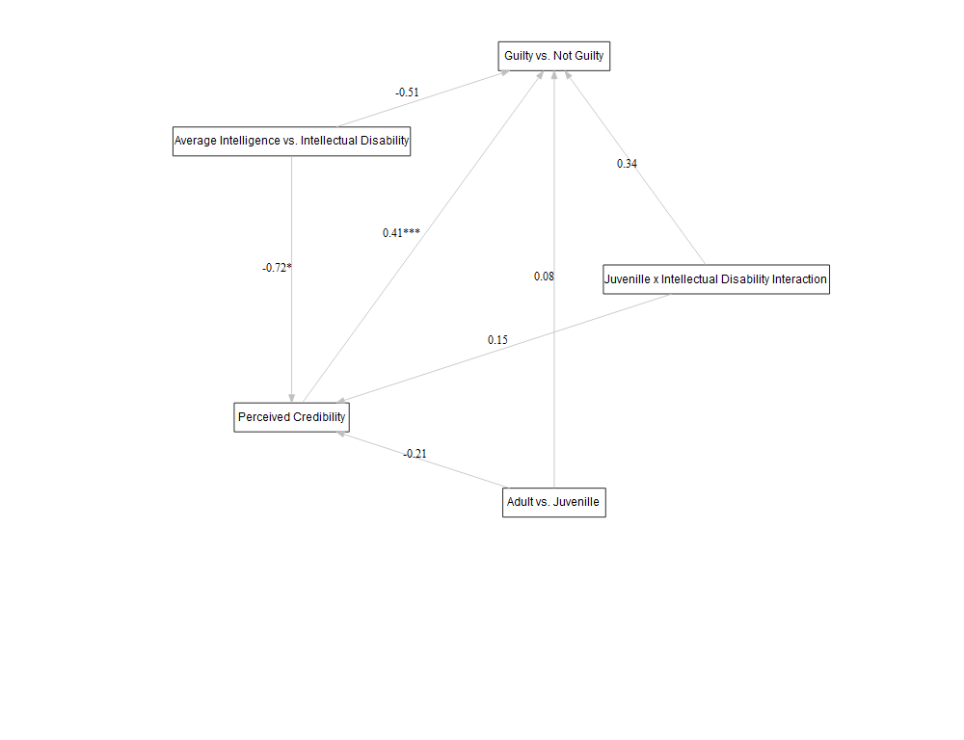

lavaanPlot(model = fit2,   
 graph_options = list(rankdir = "RL"),  
 labels = labels2,  
 node_options = list(shape = "box", fontname = "Helvetica"),  
 edge_options = list(color = "grey"), coefs = TRUE, stars="regress")

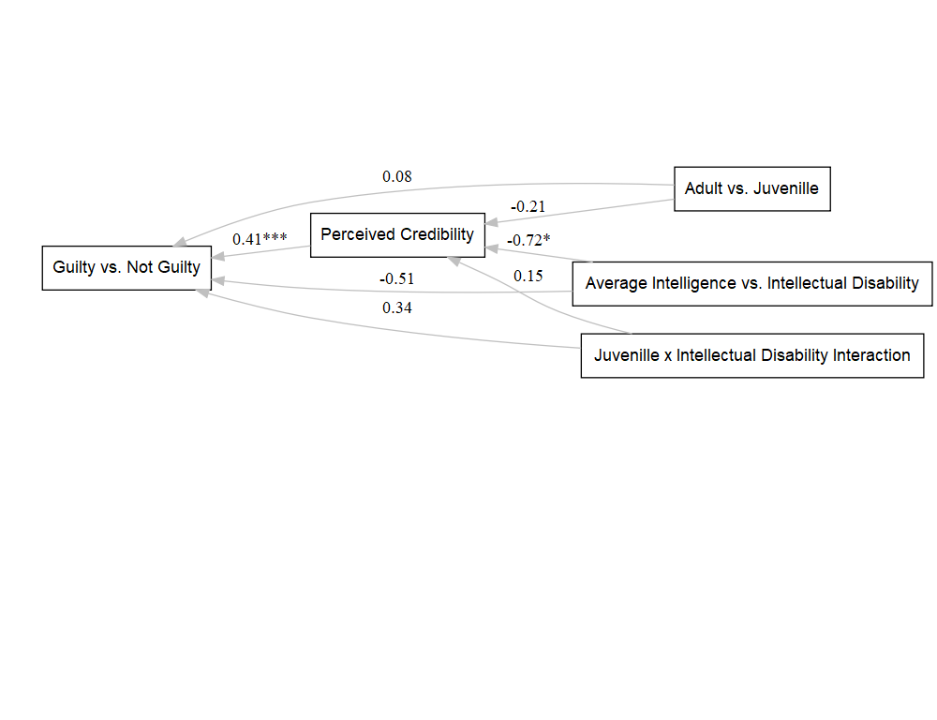

lavaanPlot(model = fit2,   
 graph_options = list(rankdir = "BT"),  
 labels = labels2,  
 node_options = list(shape = "box", fontname = "Helvetica"),  
 edge_options = list(color = "grey"), coefs = TRUE, stars="regress")

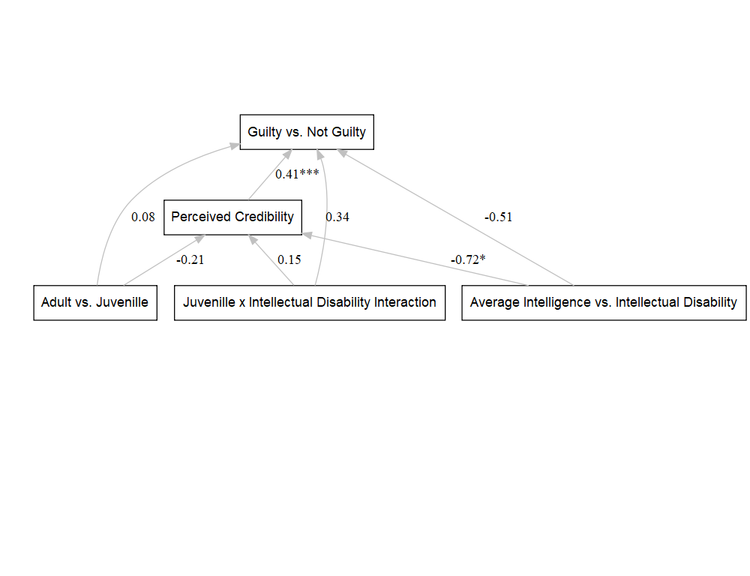

#same results as with guilt   
#######################  
#same models but without the direct effects on guilt   
  
  
library(lavaan)  
# Specify the model  
model3 <- '  
 # Mediation part  
 perc ~ a1*juv.rev + a2*dis + a3*interaction_term.r   
 guilt ~ b1*perc   
   
 # Indirect effect  
 indirect_juv := a1 * b1 # Indirect effect of juv through perc  
 indirect_dis := a2 * b1 # Indirect effect of dis through perc  
 indirect_int := a3 * b1 # Indirect effect of the interaction term through perc  
   
'  
  
# Fit the model using the lavaan function  
fit3 <- sem(model3, data = d)  
  
  
# Display a summary of the results  
summary(fit3)

## lavaan 0.6-19 ended normally after 1 iteration  
##   
## Estimator ML  
## Optimization method NLMINB  
## Number of model parameters 6  
##   
## Number of observations 185  
##   
## Model Test User Model:  
##   
## Test statistic 2.378  
## Degrees of freedom 3  
## P-value (Chi-square) 0.498  
##   
## Parameter Estimates:  
##   
## Standard errors Standard  
## Information Expected  
## Information saturated (h1) model Structured  
##   
## Regressions:  
## Estimate Std.Err z-value P(>|z|)  
## perc ~   
## juv.rev (a1) -0.205 0.324 -0.635 0.525  
## dis (a2) -0.721 0.315 -2.292 0.022  
## intrctn_. (a3) 0.148 0.462 0.320 0.749  
## guilt ~   
## perc (b1) 0.681 0.055 12.491 0.000  
##   
## Variances:  
## Estimate Std.Err z-value P(>|z|)  
## .perc 2.451 0.255 9.618 0.000  
## .guilt 1.411 0.147 9.618 0.000  
##   
## Defined Parameters:  
## Estimate Std.Err z-value P(>|z|)  
## indirect_juv -0.140 0.221 -0.634 0.526  
## indirect_dis -0.491 0.218 -2.254 0.024  
## indirect_int 0.101 0.315 0.320 0.749

summary(fit3, standardized = TRUE, fit.measures = TRUE)

## lavaan 0.6-19 ended normally after 1 iteration  
##   
## Estimator ML  
## Optimization method NLMINB  
## Number of model parameters 6  
##   
## Number of observations 185  
##   
## Model Test User Model:  
##   
## Test statistic 2.378  
## Degrees of freedom 3  
## P-value (Chi-square) 0.498  
##   
## Model Test Baseline Model:  
##   
## Test statistic 123.783  
## Degrees of freedom 7  
## P-value 0.000  
##   
## User Model versus Baseline Model:  
##   
## Comparative Fit Index (CFI) 1.000  
## Tucker-Lewis Index (TLI) 1.012  
##   
## Loglikelihood and Information Criteria:  
##   
## Loglikelihood user model (H0) -639.751  
## Loglikelihood unrestricted model (H1) NA  
##   
## Akaike (AIC) 1291.501  
## Bayesian (BIC) 1310.823  
## Sample-size adjusted Bayesian (SABIC) 1291.819  
##   
## Root Mean Square Error of Approximation:  
##   
## RMSEA 0.000  
## 90 Percent confidence interval - lower 0.000  
## 90 Percent confidence interval - upper 0.114  
## P-value H_0: RMSEA <= 0.050 0.670  
## P-value H_0: RMSEA >= 0.080 0.167  
##   
## Standardized Root Mean Square Residual:  
##   
## SRMR 0.024  
##   
## Parameter Estimates:  
##   
## Standard errors Standard  
## Information Expected  
## Information saturated (h1) model Structured  
##   
## Regressions:  
## Estimate Std.Err z-value P(>|z|) Std.lv Std.all  
## perc ~   
## juv.rev (a1) -0.205 0.324 -0.635 0.525 -0.205 -0.064  
## dis (a2) -0.721 0.315 -2.292 0.022 -0.721 -0.225  
## intrctn_. (a3) 0.148 0.462 0.320 0.749 0.148 0.039  
## guilt ~   
## perc (b1) 0.681 0.055 12.491 0.000 0.681 0.676  
##   
## Variances:  
## Estimate Std.Err z-value P(>|z|) Std.lv Std.all  
## .perc 2.451 0.255 9.618 0.000 2.451 0.956  
## .guilt 1.411 0.147 9.618 0.000 1.411 0.542  
##   
## Defined Parameters:  
## Estimate Std.Err z-value P(>|z|) Std.lv Std.all  
## indirect_juv -0.140 0.221 -0.634 0.526 -0.140 -0.043  
## indirect_dis -0.491 0.218 -2.254 0.024 -0.491 -0.152  
## indirect_int 0.101 0.315 0.320 0.749 0.101 0.026

# To view the estimates for indirect  
parameterEstimates(fit3, ci = TRUE, standardized = TRUE)

## lhs op rhs label est se z  
## 1 perc ~ juv.rev a1 -0.205 0.324 -0.635  
## 2 perc ~ dis a2 -0.721 0.315 -2.292  
## 3 perc ~ interaction_term.r a3 0.148 0.462 0.320  
## 4 guilt ~ perc b1 0.681 0.055 12.491  
## 5 perc ~~ perc 2.451 0.255 9.618  
## 6 guilt ~~ guilt 1.411 0.147 9.618  
## 7 juv.rev ~~ juv.rev 0.249 0.000 NA  
## 8 juv.rev ~~ dis -0.002 0.000 NA  
## 9 juv.rev ~~ interaction_term.r 0.121 0.000 NA  
## 10 dis ~~ dis 0.250 0.000 NA  
## 11 dis ~~ interaction_term.r 0.115 0.000 NA  
## 12 interaction_term.r ~~ interaction_term.r 0.175 0.000 NA  
## 13 indirect_juv := a1*b1 indirect_juv -0.140 0.221 -0.634  
## 14 indirect_dis := a2*b1 indirect_dis -0.491 0.218 -2.254  
## 15 indirect_int := a3*b1 indirect_int 0.101 0.315 0.320  
## pvalue ci.lower ci.upper std.lv std.all std.nox  
## 1 0.525 -0.840 0.429 -0.205 -0.064 -0.128  
## 2 0.022 -1.338 -0.104 -0.721 -0.225 -0.451  
## 3 0.749 -0.757 1.052 0.148 0.039 0.092  
## 4 0.000 0.574 0.788 0.681 0.676 0.676  
## 5 0.000 1.951 2.950 2.451 0.956 0.956  
## 6 0.000 1.123 1.698 1.411 0.542 0.542  
## 7 NA 0.249 0.249 0.249 1.000 0.249  
## 8 NA -0.002 -0.002 -0.002 -0.007 -0.002  
## 9 NA 0.121 0.121 0.121 0.581 0.121  
## 10 NA 0.250 0.250 0.250 1.000 0.250  
## 11 NA 0.115 0.115 0.115 0.551 0.115  
## 12 NA 0.175 0.175 0.175 1.000 0.175  
## 13 0.526 -0.573 0.293 -0.140 -0.043 -0.087  
## 14 0.024 -0.919 -0.064 -0.491 -0.152 -0.305  
## 15 0.749 -0.516 0.717 0.101 0.026 0.062

parameterEstimates(fit3, boot.ci.type = "bca.simple")

## lhs op rhs label est se z  
## 1 perc ~ juv.rev a1 -0.205 0.324 -0.635  
## 2 perc ~ dis a2 -0.721 0.315 -2.292  
## 3 perc ~ interaction_term.r a3 0.148 0.462 0.320  
## 4 guilt ~ perc b1 0.681 0.055 12.491  
## 5 perc ~~ perc 2.451 0.255 9.618  
## 6 guilt ~~ guilt 1.411 0.147 9.618  
## 7 juv.rev ~~ juv.rev 0.249 0.000 NA  
## 8 juv.rev ~~ dis -0.002 0.000 NA  
## 9 juv.rev ~~ interaction_term.r 0.121 0.000 NA  
## 10 dis ~~ dis 0.250 0.000 NA  
## 11 dis ~~ interaction_term.r 0.115 0.000 NA  
## 12 interaction_term.r ~~ interaction_term.r 0.175 0.000 NA  
## 13 indirect_juv := a1*b1 indirect_juv -0.140 0.221 -0.634  
## 14 indirect_dis := a2*b1 indirect_dis -0.491 0.218 -2.254  
## 15 indirect_int := a3*b1 indirect_int 0.101 0.315 0.320  
## pvalue ci.lower ci.upper  
## 1 0.525 -0.840 0.429  
## 2 0.022 -1.338 -0.104  
## 3 0.749 -0.757 1.052  
## 4 0.000 0.574 0.788  
## 5 0.000 1.951 2.950  
## 6 0.000 1.123 1.698  
## 7 NA 0.249 0.249  
## 8 NA -0.002 -0.002  
## 9 NA 0.121 0.121  
## 10 NA 0.250 0.250  
## 11 NA 0.115 0.115  
## 12 NA 0.175 0.175  
## 13 0.526 -0.573 0.293  
## 14 0.024 -0.919 -0.064  
## 15 0.749 -0.516 0.717

#plotting   
library(lavaanPlot)  
labels = list(guilt = "Guilty", perc = "Perceived Credibility", juv.rev= "Adult vs. Juvenille", dis="Average Intelligence vs. Intellectual Disability",  
 interaction_term.r="Juvenille x Intellectual Disability Interaction")  
  
lavaanPlot(model = fit3,   
 graph_options = list(layout = "circo"),  
 labels = labels,  
 node_options = list(shape = "box", fontname = "Helvetica"),  
 edge_options = list(color = "grey"), coefs = TRUE, stars="regress")

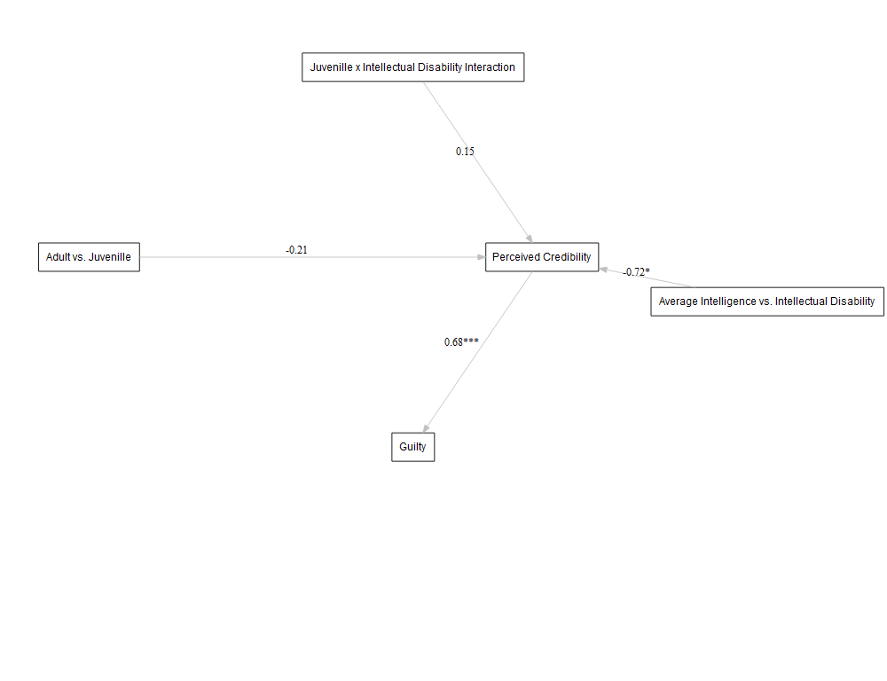

lavaanPlot(model = fit3,   
 graph_options = list(rankdir = "RL"),  
 labels = labels,  
 node_options = list(shape = "box", fontname = "Helvetica"),  
 edge_options = list(color = "grey"), coefs = TRUE, stars="regress")

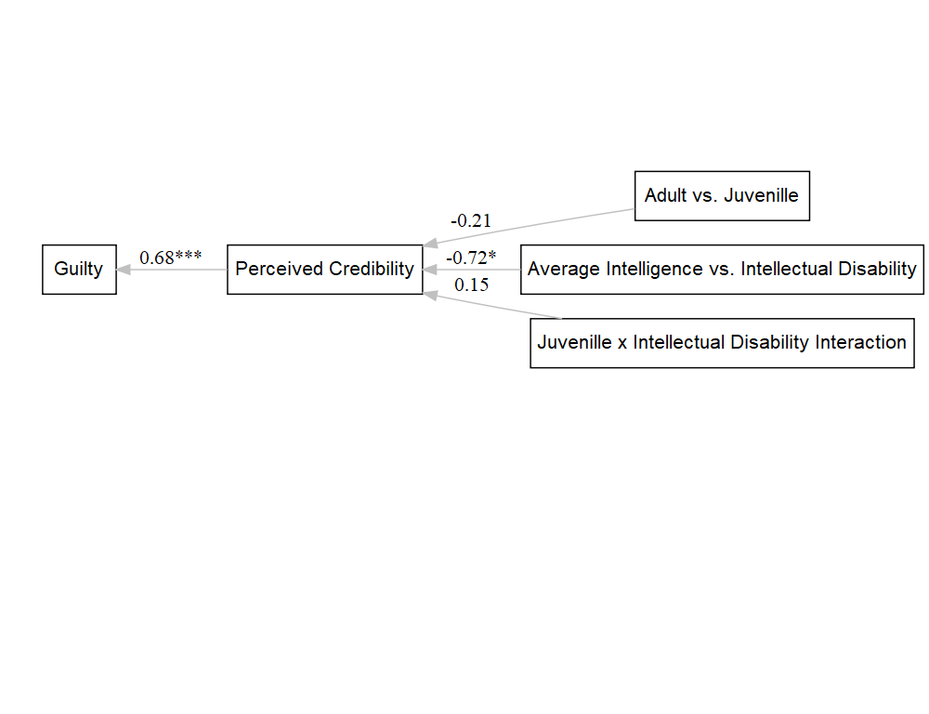

lavaanPlot(model = fit3,   
 graph_options = list(rankdir = "BT"),  
 labels = labels,  
 node_options = list(shape = "box", fontname = "Helvetica"),  
 edge_options = list(color = "grey"), coefs = TRUE, stars="regress")

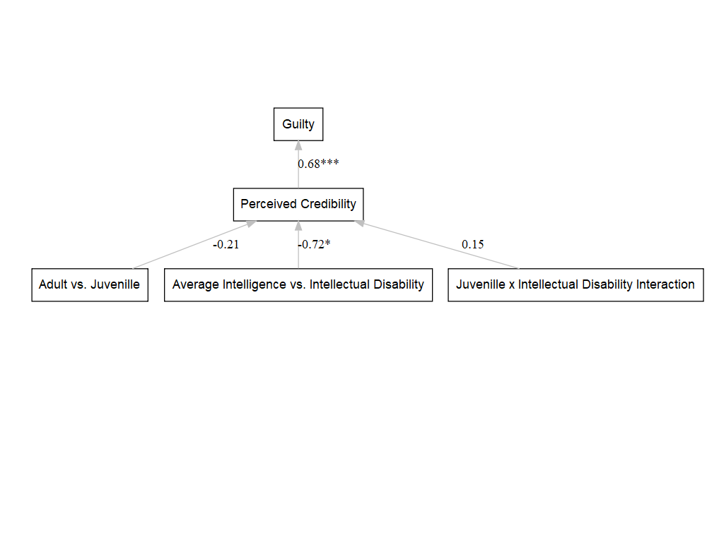

###########################  
  
library(lavaan)  
# Specify model  
model4 <- '  
 # Mediation part  
 perc ~ a1*juv.rev + a2*dis + a3*interaction_term.r   
 guilt.dichot ~ b1*perc   
   
 # Indirect effect  
 indirect_juv := a1 * b1 # Indirect effect of juv through perc  
 indirect_dis := a2 * b1 # Indirect effect of dis through perc  
 indirect_int := a3 * b1 # Indirect effect of the interaction term through perc  
   
'  
  
# Fit the model using the lavaan function  
fit4 <- sem(model4, data = d, ordered = "guilt.dichot")  
summary(fit4)

## lavaan 0.6-19 ended normally after 35 iterations  
##   
## Estimator DWLS  
## Optimization method NLMINB  
## Number of model parameters 7  
##   
## Number of observations 185  
##   
## Model Test User Model:  
## Standard Scaled  
## Test Statistic 2.784 4.271  
## Degrees of freedom 3 3  
## P-value (Chi-square) 0.426 0.234  
## Scaling correction factor 0.780  
## Shift parameter 0.704  
## simple second-order correction   
##   
## Parameter Estimates:  
##   
## Parameterization Delta  
## Standard errors Robust.sem  
## Information Expected  
## Information saturated (h1) model Unstructured  
##   
## Regressions:  
## Estimate Std.Err z-value P(>|z|)  
## perc ~   
## juv.rev (a1) -0.166 0.330 -0.503 0.615  
## dis (a2) -0.914 0.338 -2.702 0.007  
## intrctn_. (a3) 0.293 0.501 0.585 0.559  
## guilt.dichot ~   
## perc (b1) 0.440 0.040 11.110 0.000  
##   
## Intercepts:  
## Estimate Std.Err z-value P(>|z|)  
## .perc 3.865 0.489 7.901 0.000  
##   
## Thresholds:  
## Estimate Std.Err z-value P(>|z|)  
## guilt.dicht|t1 2.163 0.341 6.340 0.000  
##   
## Variances:  
## Estimate Std.Err z-value P(>|z|)  
## .perc 2.362 0.344 6.863 0.000  
## .guilt.dichot 0.543   
##   
## Defined Parameters:  
## Estimate Std.Err z-value P(>|z|)  
## indirect_juv -0.073 0.145 -0.501 0.616  
## indirect_dis -0.402 0.155 -2.586 0.010  
## indirect_int 0.129 0.222 0.582 0.561

# view the estimates  
parameterEstimates(fit4, ci = TRUE, standardized = TRUE)

## lhs op rhs label est se z  
## 1 perc ~ juv.rev a1 -0.166 0.330 -0.503  
## 2 perc ~ dis a2 -0.914 0.338 -2.702  
## 3 perc ~ interaction_term.r a3 0.293 0.501 0.585  
## 4 guilt.dichot ~ perc b1 0.440 0.040 11.110  
## 5 guilt.dichot | t1 2.163 0.341 6.340  
## 6 perc ~~ perc 2.362 0.344 6.863  
## 7 guilt.dichot ~~ guilt.dichot 0.543 0.000 NA  
## 8 juv.rev ~~ juv.rev 0.250 0.000 NA  
## 9 juv.rev ~~ dis -0.002 0.000 NA  
## 10 juv.rev ~~ interaction_term.r 0.122 0.000 NA  
## 11 dis ~~ dis 0.251 0.000 NA  
## 12 dis ~~ interaction_term.r 0.116 0.000 NA  
## 13 interaction_term.r ~~ interaction_term.r 0.176 0.000 NA  
## 14 guilt.dichot ~*~ guilt.dichot 1.000 0.000 NA  
## 15 perc ~1 3.865 0.489 7.901  
## 16 guilt.dichot ~1 0.000 0.000 NA  
## 17 juv.rev ~1 1.465 0.000 NA  
## 18 dis ~1 0.492 0.000 NA  
## 19 interaction_term.r ~1 0.227 0.000 NA  
## 20 indirect_juv := a1*b1 indirect_juv -0.073 0.145 -0.501  
## 21 indirect_dis := a2*b1 indirect_dis -0.402 0.155 -2.586  
## 22 indirect_int := a3*b1 indirect_int 0.129 0.222 0.582  
## pvalue ci.lower ci.upper std.lv std.all std.nox  
## 1 0.615 -0.812 0.481 -0.166 -0.052 -0.104  
## 2 0.007 -1.577 -0.251 -0.914 -0.289 -0.576  
## 3 0.559 -0.689 1.275 0.293 0.078 0.185  
## 4 0.000 0.362 0.517 0.440 0.688 0.688  
## 5 0.000 1.494 2.831 2.163 2.131 2.131  
## 6 0.000 1.687 3.036 2.362 0.938 0.938  
## 7 NA 0.543 0.543 0.543 0.527 0.527  
## 8 NA 0.250 0.250 0.250 1.000 0.250  
## 9 NA -0.002 -0.002 -0.002 -0.007 -0.002  
## 10 NA 0.122 0.122 0.122 0.581 0.122  
## 11 NA 0.251 0.251 0.251 1.000 0.251  
## 12 NA 0.116 0.116 0.116 0.551 0.116  
## 13 NA 0.176 0.176 0.176 1.000 0.176  
## 14 NA 1.000 1.000 1.000 1.000 1.000  
## 15 0.000 2.907 4.824 3.865 2.435 2.435  
## 16 NA 0.000 0.000 0.000 0.000 0.000  
## 17 NA 1.465 1.465 1.465 2.929 1.465  
## 18 NA 0.492 0.492 0.492 0.981 0.492  
## 19 NA 0.227 0.227 0.227 0.540 0.227  
## 20 0.616 -0.358 0.212 -0.073 -0.036 -0.072  
## 21 0.010 -0.707 -0.097 -0.402 -0.198 -0.396  
## 22 0.561 -0.305 0.563 0.129 0.053 0.127

parameterEstimates(fit4, boot.ci.type = "bca.simple")

## lhs op rhs label est se z  
## 1 perc ~ juv.rev a1 -0.166 0.330 -0.503  
## 2 perc ~ dis a2 -0.914 0.338 -2.702  
## 3 perc ~ interaction_term.r a3 0.293 0.501 0.585  
## 4 guilt.dichot ~ perc b1 0.440 0.040 11.110  
## 5 guilt.dichot | t1 2.163 0.341 6.340  
## 6 perc ~~ perc 2.362 0.344 6.863  
## 7 guilt.dichot ~~ guilt.dichot 0.543 0.000 NA  
## 8 juv.rev ~~ juv.rev 0.250 0.000 NA  
## 9 juv.rev ~~ dis -0.002 0.000 NA  
## 10 juv.rev ~~ interaction_term.r 0.122 0.000 NA  
## 11 dis ~~ dis 0.251 0.000 NA  
## 12 dis ~~ interaction_term.r 0.116 0.000 NA  
## 13 interaction_term.r ~~ interaction_term.r 0.176 0.000 NA  
## 14 guilt.dichot ~*~ guilt.dichot 1.000 0.000 NA  
## 15 perc ~1 3.865 0.489 7.901  
## 16 guilt.dichot ~1 0.000 0.000 NA  
## 17 juv.rev ~1 1.465 0.000 NA  
## 18 dis ~1 0.492 0.000 NA  
## 19 interaction_term.r ~1 0.227 0.000 NA  
## 20 indirect_juv := a1*b1 indirect_juv -0.073 0.145 -0.501  
## 21 indirect_dis := a2*b1 indirect_dis -0.402 0.155 -2.586  
## 22 indirect_int := a3*b1 indirect_int 0.129 0.222 0.582  
## pvalue ci.lower ci.upper  
## 1 0.615 -0.812 0.481  
## 2 0.007 -1.577 -0.251  
## 3 0.559 -0.689 1.275  
## 4 0.000 0.362 0.517  
## 5 0.000 1.494 2.831  
## 6 0.000 1.687 3.036  
## 7 NA 0.543 0.543  
## 8 NA 0.250 0.250  
## 9 NA -0.002 -0.002  
## 10 NA 0.122 0.122  
## 11 NA 0.251 0.251  
## 12 NA 0.116 0.116  
## 13 NA 0.176 0.176  
## 14 NA 1.000 1.000  
## 15 0.000 2.907 4.824  
## 16 NA 0.000 0.000  
## 17 NA 1.465 1.465  
## 18 NA 0.492 0.492  
## 19 NA 0.227 0.227  
## 20 0.616 -0.358 0.212  
## 21 0.010 -0.707 -0.097  
## 22 0.561 -0.305 0.563

library(lavaanPlot)  
  
lavaanPlot(model = fit4,   
 graph_options = list(layout = "circo"),  
 labels = labels2,  
 node_options = list(shape = "box", fontname = "Helvetica"),  
 edge_options = list(color = "grey"), coefs = TRUE, stars="regress")

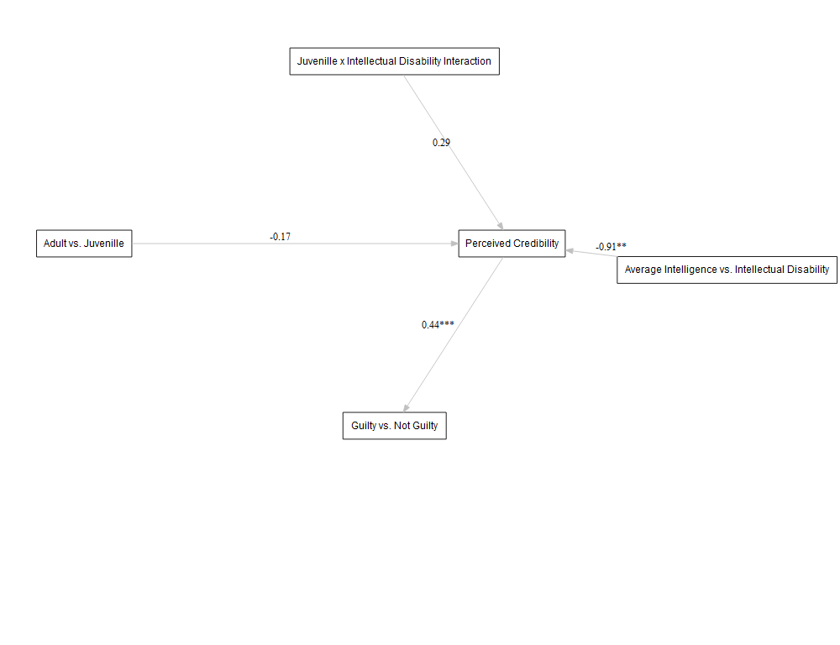

lavaanPlot(model = fit4,   
 graph_options = list(rankdir = "RL"),  
 labels = labels2,  
 node_options = list(shape = "box", fontname = "Helvetica"),  
 edge_options = list(color = "grey"), coefs = TRUE, stars="regress")

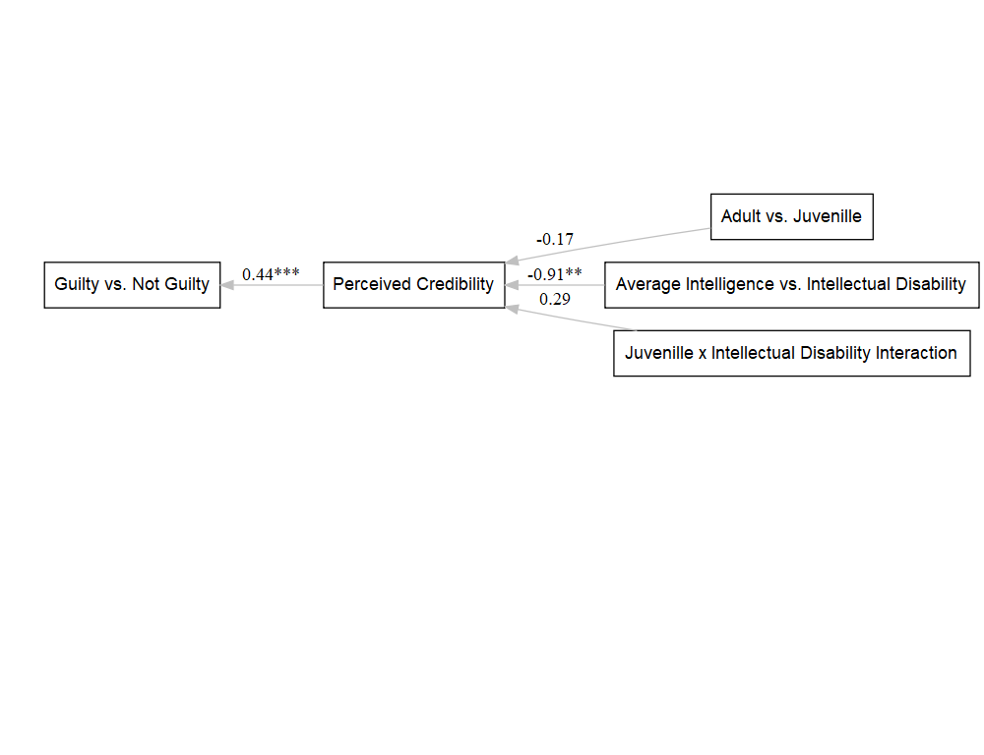

lavaanPlot(model = fit4,   
 graph_options = list(rankdir = "BT"),  
 labels = labels2,  
 node_options = list(shape = "box", fontname = "Helvetica"),  
 edge_options = list(color = "grey"), coefs = TRUE, stars="regress")

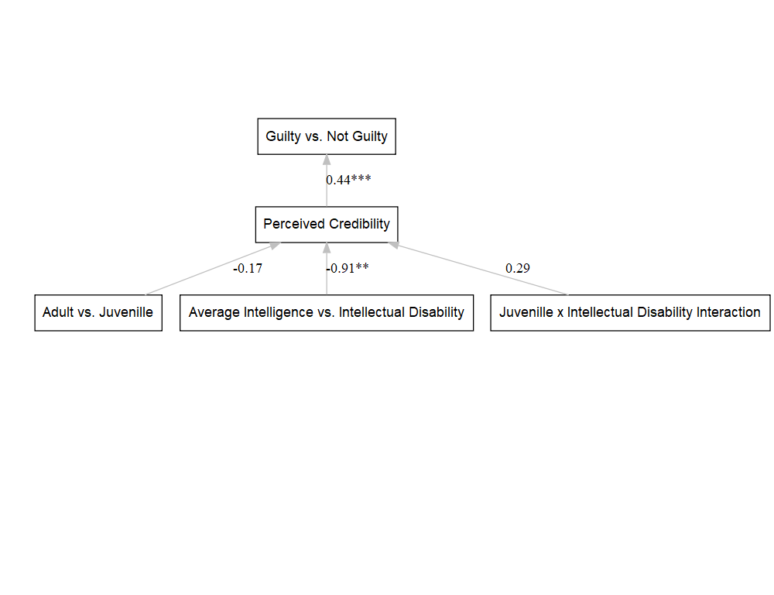

#############################  
#leaving out the interaction   
  
  
library(lavaan)  
# Specify the model  
model5 <- '  
 # Mediation part  
 perc ~ a1*juv + a2*dis   
 guilt ~ b1*perc   
   
 # Indirect effect  
 indirect_juv := a1 * b1 # Indirect effect of juv through perc  
 indirect_dis := a2 * b1 # Indirect effect of dis through perc  
  
'  
  
# Fit the model using the lavaan function  
fit5 <- sem(model5, data = d)  
  
  
# Display a summary of the results  
summary(fit5)

## lavaan 0.6-19 ended normally after 1 iteration  
##   
## Estimator ML  
## Optimization method NLMINB  
## Number of model parameters 5  
##   
## Number of observations 185  
##   
## Model Test User Model:  
##   
## Test statistic 1.069  
## Degrees of freedom 2  
## P-value (Chi-square) 0.586  
##   
## Parameter Estimates:  
##   
## Standard errors Standard  
## Information Expected  
## Information saturated (h1) model Structured  
##   
## Regressions:  
## Estimate Std.Err z-value P(>|z|)  
## perc ~   
## juv (a1) 0.133 0.231 0.576 0.565  
## dis (a2) -0.653 0.230 -2.834 0.005  
## guilt ~   
## perc (b1) 0.681 0.055 12.491 0.000  
##   
## Variances:  
## Estimate Std.Err z-value P(>|z|)  
## .perc 2.452 0.255 9.618 0.000  
## .guilt 1.411 0.147 9.618 0.000  
##   
## Defined Parameters:  
## Estimate Std.Err z-value P(>|z|)  
## indirect_juv 0.091 0.157 0.575 0.565  
## indirect_dis -0.445 0.161 -2.764 0.006

summary(fit5, standardized = TRUE, fit.measures = TRUE)

## lavaan 0.6-19 ended normally after 1 iteration  
##   
## Estimator ML  
## Optimization method NLMINB  
## Number of model parameters 5  
##   
## Number of observations 185  
##   
## Model Test User Model:  
##   
## Test statistic 1.069  
## Degrees of freedom 2  
## P-value (Chi-square) 0.586  
##   
## Model Test Baseline Model:  
##   
## Test statistic 122.372  
## Degrees of freedom 5  
## P-value 0.000  
##   
## User Model versus Baseline Model:  
##   
## Comparative Fit Index (CFI) 1.000  
## Tucker-Lewis Index (TLI) 1.020  
##   
## Loglikelihood and Information Criteria:  
##   
## Loglikelihood user model (H0) -639.802  
## Loglikelihood unrestricted model (H1) -639.267  
##   
## Akaike (AIC) 1289.603  
## Bayesian (BIC) 1305.705  
## Sample-size adjusted Bayesian (SABIC) 1289.869  
##   
## Root Mean Square Error of Approximation:  
##   
## RMSEA 0.000  
## 90 Percent confidence interval - lower 0.000  
## 90 Percent confidence interval - upper 0.121  
## P-value H_0: RMSEA <= 0.050 0.709  
## P-value H_0: RMSEA >= 0.080 0.167  
##   
## Standardized Root Mean Square Residual:  
##   
## SRMR 0.017  
##   
## Parameter Estimates:  
##   
## Standard errors Standard  
## Information Expected  
## Information saturated (h1) model Structured  
##   
## Regressions:  
## Estimate Std.Err z-value P(>|z|) Std.lv Std.all  
## perc ~   
## juv (a1) 0.133 0.231 0.576 0.565 0.133 0.041  
## dis (a2) -0.653 0.230 -2.834 0.005 -0.653 -0.204  
## guilt ~   
## perc (b1) 0.681 0.055 12.491 0.000 0.681 0.676  
##   
## Variances:  
## Estimate Std.Err z-value P(>|z|) Std.lv Std.all  
## .perc 2.452 0.255 9.618 0.000 2.452 0.957  
## .guilt 1.411 0.147 9.618 0.000 1.411 0.542  
##   
## Defined Parameters:  
## Estimate Std.Err z-value P(>|z|) Std.lv Std.all  
## indirect_juv 0.091 0.157 0.575 0.565 0.091 0.028  
## indirect_dis -0.445 0.161 -2.764 0.006 -0.445 -0.138

# To view the estimates for indirect  
parameterEstimates(fit5, ci = TRUE, standardized = TRUE)

## lhs op rhs label est se z pvalue ci.lower  
## 1 perc ~ juv a1 0.133 0.231 0.576 0.565 -0.320  
## 2 perc ~ dis a2 -0.653 0.230 -2.834 0.005 -1.104  
## 3 guilt ~ perc b1 0.681 0.055 12.491 0.000 0.574  
## 4 perc ~~ perc 2.452 0.255 9.618 0.000 1.952  
## 5 guilt ~~ guilt 1.411 0.147 9.618 0.000 1.123  
## 6 juv ~~ juv 0.249 0.000 NA NA 0.249  
## 7 juv ~~ dis 0.002 0.000 NA NA 0.002  
## 8 dis ~~ dis 0.250 0.000 NA NA 0.250  
## 9 indirect_juv := a1*b1 indirect_juv 0.091 0.157 0.575 0.565 -0.218  
## 10 indirect_dis := a2*b1 indirect_dis -0.445 0.161 -2.764 0.006 -0.760  
## ci.upper std.lv std.all std.nox  
## 1 0.585 0.133 0.041 0.083  
## 2 -0.201 -0.653 -0.204 -0.408  
## 3 0.788 0.681 0.676 0.676  
## 4 2.952 2.452 0.957 0.957  
## 5 1.698 1.411 0.542 0.542  
## 6 0.249 0.249 1.000 0.249  
## 7 0.002 0.002 0.007 0.002  
## 8 0.250 0.250 1.000 0.250  
## 9 0.399 0.091 0.028 0.056  
## 10 -0.129 -0.445 -0.138 -0.276

parameterEstimates(fit5, boot.ci.type = "bca.simple")

## lhs op rhs label est se z pvalue ci.lower  
## 1 perc ~ juv a1 0.133 0.231 0.576 0.565 -0.320  
## 2 perc ~ dis a2 -0.653 0.230 -2.834 0.005 -1.104  
## 3 guilt ~ perc b1 0.681 0.055 12.491 0.000 0.574  
## 4 perc ~~ perc 2.452 0.255 9.618 0.000 1.952  
## 5 guilt ~~ guilt 1.411 0.147 9.618 0.000 1.123  
## 6 juv ~~ juv 0.249 0.000 NA NA 0.249  
## 7 juv ~~ dis 0.002 0.000 NA NA 0.002  
## 8 dis ~~ dis 0.250 0.000 NA NA 0.250  
## 9 indirect_juv := a1*b1 indirect_juv 0.091 0.157 0.575 0.565 -0.218  
## 10 indirect_dis := a2*b1 indirect_dis -0.445 0.161 -2.764 0.006 -0.760  
## ci.upper  
## 1 0.585  
## 2 -0.201  
## 3 0.788  
## 4 2.952  
## 5 1.698  
## 6 0.249  
## 7 0.002  
## 8 0.250  
## 9 0.399  
## 10 -0.129

#plotting   
library(lavaanPlot)  
labels3 = list(guilt = "Guilty", perc = "Perceived Credibility", juv= "Juvenille vs. Adult",   
 dis="Average Intelligence vs. Intellectual Disability")  
  
lavaanPlot(model = fit5,   
 graph_options = list(layout = "circo"),  
 labels = labels3,  
 node_options = list(shape = "box", fontname = "Helvetica"),  
 edge_options = list(color = "grey"), coefs = TRUE, stars="regress")

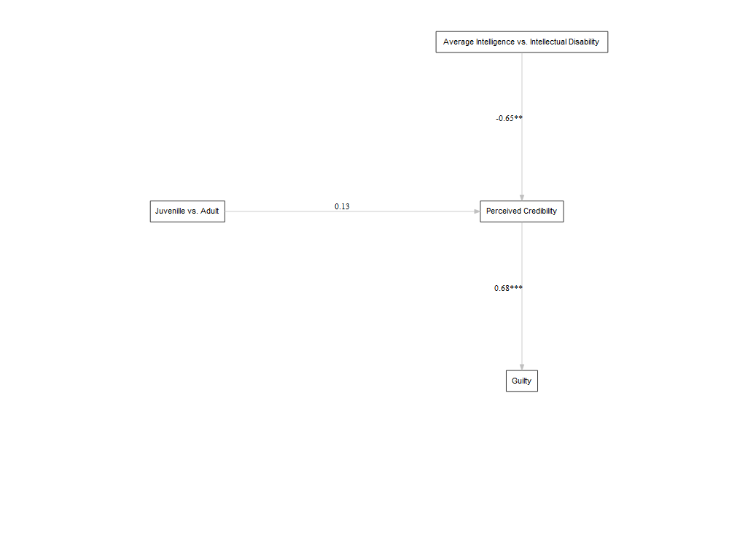

lavaanPlot(model = fit5,   
 graph_options = list(rankdir = "RL"),  
 labels = labels3,  
 node_options = list(shape = "box", fontname = "Helvetica"),  
 edge_options = list(color = "grey"), coefs = TRUE, stars="regress")

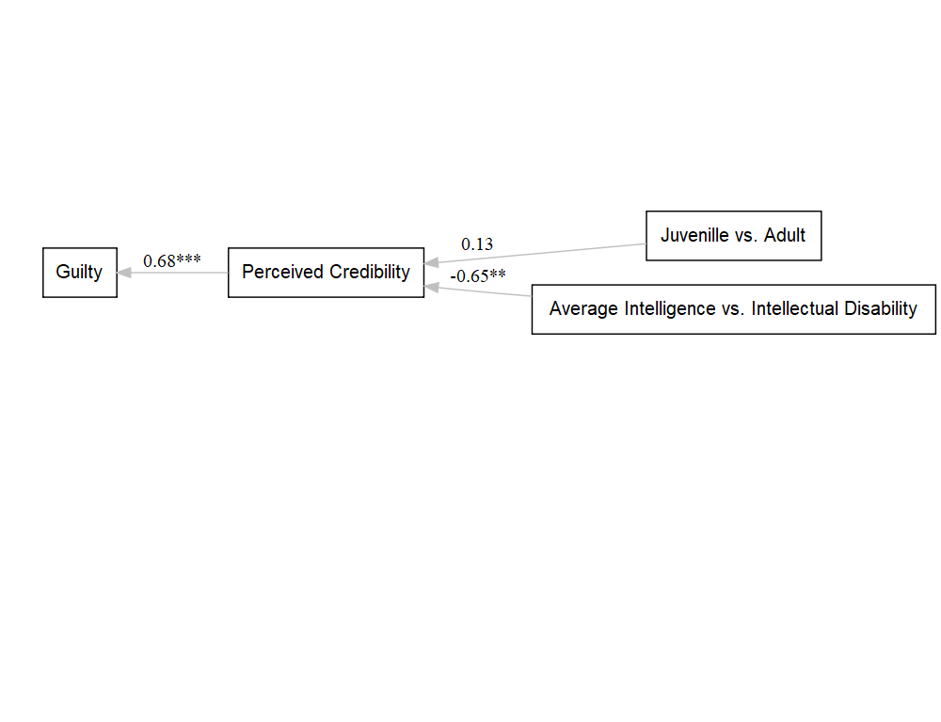

lavaanPlot(model = fit5,   
 graph_options = list(rankdir = "BT"),  
 labels = labels3,  
 node_options = list(shape = "box", fontname = "Helvetica"),  
 edge_options = list(color = "grey"), coefs = TRUE, stars="regress")

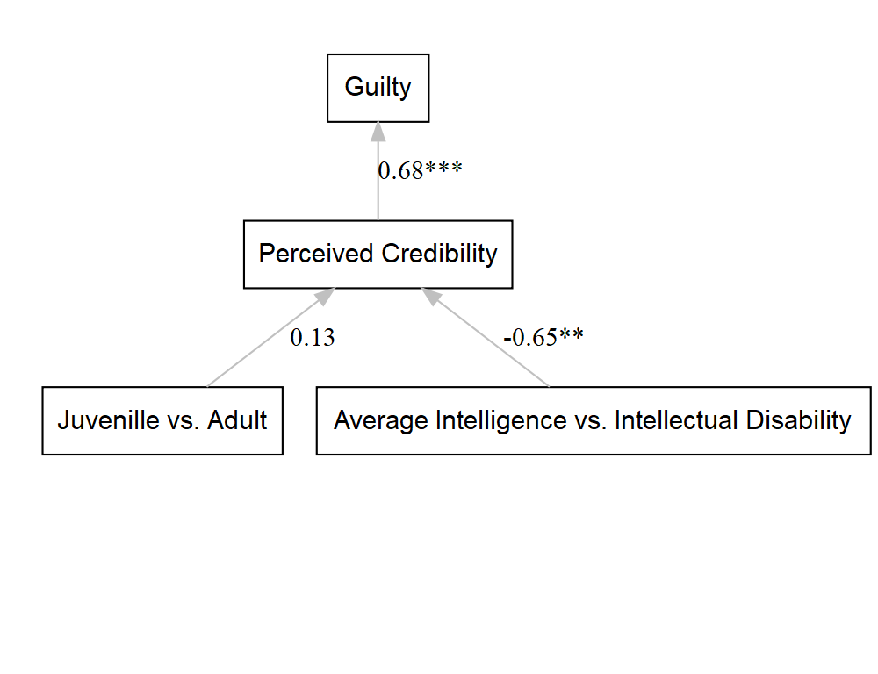

#####################  
  
library(lavaan)  
# Specify model  
model6 <- '  
 # Mediation part  
 perc ~ a1*juv + a2*dis   
 guilt.dichot ~ b1*perc   
   
 # Indirect effect  
 indirect_juv := a1 * b1 # Indirect effect of juv through perc  
 indirect_dis := a2 * b1 # Indirect effect of dis through perc  
  
   
'  
  
# Fit the model   
fit6 <- sem(model6, data = d, ordered = "guilt.dichot")  
summary(fit6)

## lavaan 0.6-19 ended normally after 23 iterations  
##   
## Estimator DWLS  
## Optimization method NLMINB  
## Number of model parameters 6  
##   
## Number of observations 185  
##   
## Model Test User Model:  
## Standard Scaled  
## Test Statistic 2.733 4.658  
## Degrees of freedom 2 2  
## P-value (Chi-square) 0.255 0.097  
## Scaling correction factor 0.593  
## Shift parameter 0.047  
## simple second-order correction   
##   
## Parameter Estimates:  
##   
## Parameterization Delta  
## Standard errors Robust.sem  
## Information Expected  
## Information saturated (h1) model Unstructured  
##   
## Regressions:  
## Estimate Std.Err z-value P(>|z|)  
## perc ~   
## juv (a1) 0.039 0.247 0.159 0.874  
## dis (a2) -0.788 0.248 -3.173 0.002  
## guilt.dichot ~   
## perc (b1) 0.440 0.040 10.896 0.000  
##   
## Intercepts:  
## Estimate Std.Err z-value P(>|z|)  
## .perc 3.493 0.197 17.769 0.000  
##   
## Thresholds:  
## Estimate Std.Err z-value P(>|z|)  
## guilt.dicht|t1 1.924 0.177 10.891 0.000  
##   
## Variances:  
## Estimate Std.Err z-value P(>|z|)  
## .perc 2.363 0.336 7.024 0.000  
## .guilt.dichot 0.543   
##   
## Defined Parameters:  
## Estimate Std.Err z-value P(>|z|)  
## indirect_juv 0.017 0.109 0.159 0.874  
## indirect_dis -0.347 0.116 -2.980 0.003

# view the estimates  
parameterEstimates(fit6, ci = TRUE, standardized = TRUE)

## lhs op rhs label est se z pvalue  
## 1 perc ~ juv a1 0.039 0.247 0.159 0.874  
## 2 perc ~ dis a2 -0.788 0.248 -3.173 0.002  
## 3 guilt.dichot ~ perc b1 0.440 0.040 10.896 0.000  
## 4 guilt.dichot | t1 1.924 0.177 10.891 0.000  
## 5 perc ~~ perc 2.363 0.336 7.024 0.000  
## 6 guilt.dichot ~~ guilt.dichot 0.543 0.000 NA NA  
## 7 juv ~~ juv 0.250 0.000 NA NA  
## 8 juv ~~ dis 0.002 0.000 NA NA  
## 9 dis ~~ dis 0.251 0.000 NA NA  
## 10 guilt.dichot ~*~ guilt.dichot 1.000 0.000 NA NA  
## 11 perc ~1 3.493 0.197 17.769 0.000  
## 12 guilt.dichot ~1 0.000 0.000 NA NA  
## 13 juv ~1 0.535 0.000 NA NA  
## 14 dis ~1 0.492 0.000 NA NA  
## 15 indirect_juv := a1*b1 indirect_juv 0.017 0.109 0.159 0.874  
## 16 indirect_dis := a2*b1 indirect_dis -0.347 0.116 -2.980 0.003  
## ci.lower ci.upper std.lv std.all std.nox  
## 1 -0.445 0.523 0.039 0.012 0.025  
## 2 -1.275 -0.301 -0.788 -0.249 -0.497  
## 3 0.361 0.519 0.440 0.688 0.688  
## 4 1.578 2.271 1.924 1.896 1.896  
## 5 1.704 3.023 2.363 0.938 0.938  
## 6 0.543 0.543 0.543 0.527 0.527  
## 7 0.250 0.250 0.250 1.000 0.250  
## 8 0.002 0.002 0.002 0.007 0.002  
## 9 0.251 0.251 0.251 1.000 0.251  
## 10 1.000 1.000 1.000 1.000 1.000  
## 11 3.108 3.878 3.493 2.201 2.201  
## 12 0.000 0.000 0.000 0.000 0.000  
## 13 0.535 0.535 0.535 1.070 0.535  
## 14 0.492 0.492 0.492 0.981 0.492  
## 15 -0.196 0.230 0.017 0.008 0.017  
## 16 -0.575 -0.119 -0.347 -0.171 -0.342

parameterEstimates(fit6, boot.ci.type = "bca.simple")

## lhs op rhs label est se z pvalue  
## 1 perc ~ juv a1 0.039 0.247 0.159 0.874  
## 2 perc ~ dis a2 -0.788 0.248 -3.173 0.002  
## 3 guilt.dichot ~ perc b1 0.440 0.040 10.896 0.000  
## 4 guilt.dichot | t1 1.924 0.177 10.891 0.000  
## 5 perc ~~ perc 2.363 0.336 7.024 0.000  
## 6 guilt.dichot ~~ guilt.dichot 0.543 0.000 NA NA  
## 7 juv ~~ juv 0.250 0.000 NA NA  
## 8 juv ~~ dis 0.002 0.000 NA NA  
## 9 dis ~~ dis 0.251 0.000 NA NA  
## 10 guilt.dichot ~*~ guilt.dichot 1.000 0.000 NA NA  
## 11 perc ~1 3.493 0.197 17.769 0.000  
## 12 guilt.dichot ~1 0.000 0.000 NA NA  
## 13 juv ~1 0.535 0.000 NA NA  
## 14 dis ~1 0.492 0.000 NA NA  
## 15 indirect_juv := a1*b1 indirect_juv 0.017 0.109 0.159 0.874  
## 16 indirect_dis := a2*b1 indirect_dis -0.347 0.116 -2.980 0.003  
## ci.lower ci.upper  
## 1 -0.445 0.523  
## 2 -1.275 -0.301  
## 3 0.361 0.519  
## 4 1.578 2.271  
## 5 1.704 3.023  
## 6 0.543 0.543  
## 7 0.250 0.250  
## 8 0.002 0.002  
## 9 0.251 0.251  
## 10 1.000 1.000  
## 11 3.108 3.878  
## 12 0.000 0.000  
## 13 0.535 0.535  
## 14 0.492 0.492  
## 15 -0.196 0.230  
## 16 -0.575 -0.119

labels4 = list(guilt.dichot = "Guilty vs. Not Guilty", perc = "Perceived Credibility",   
 juv= "Juvenille vs. Adult", dis="Average Intelligence vs. Intellectual Disability")  
  
library(lavaanPlot)  
  
  
lavaanPlot(model = fit6,   
 graph_options = list(layout = "circo"),  
 labels = labels4,  
 node_options = list(shape = "box", fontname = "Helvetica"),  
 edge_options = list(color = "grey"), coefs = TRUE, stars="regress")

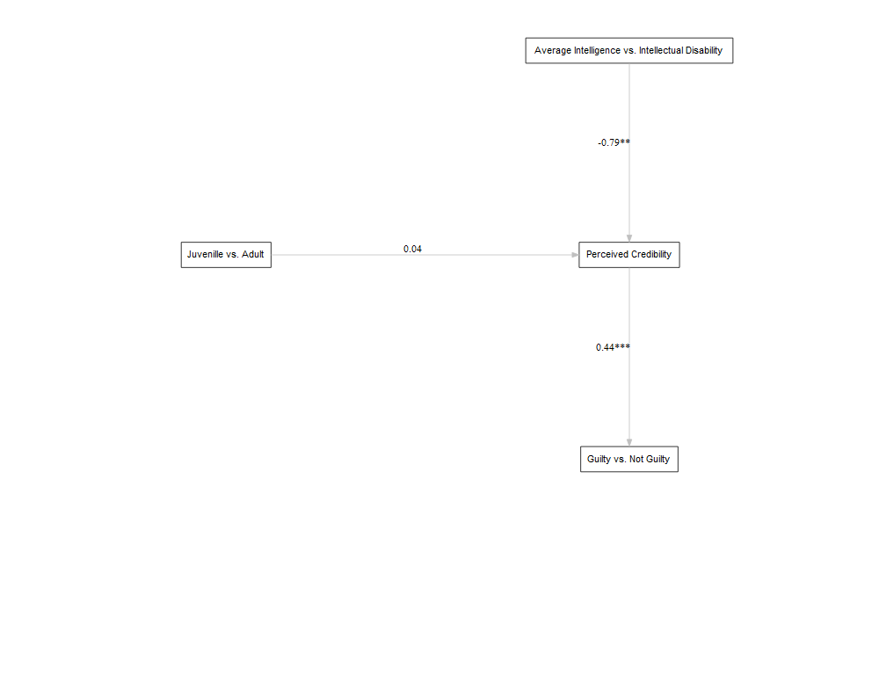

lavaanPlot(model = fit6,   
 graph_options = list(rankdir = "RL"),  
 labels = labels4,  
 node_options = list(shape = "box", fontname = "Helvetica"),  
 edge_options = list(color = "grey"), coefs = TRUE, stars="regress")

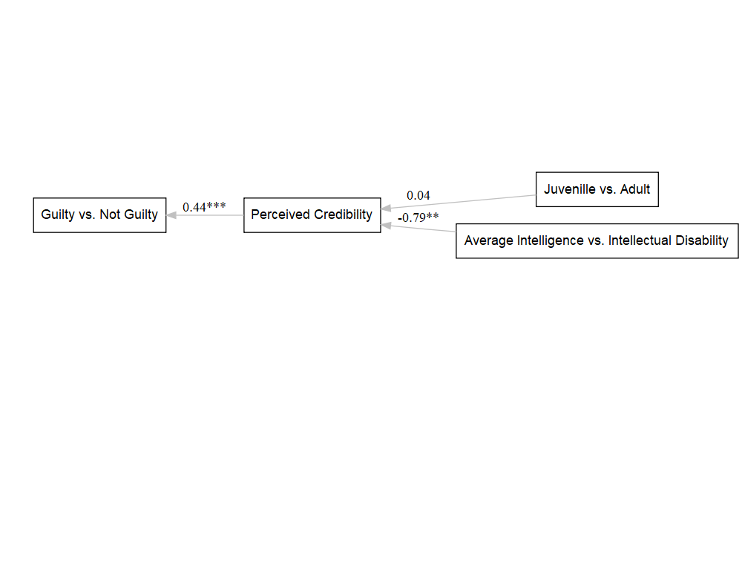

lavaanPlot(model = fit6,   
 graph_options = list(rankdir = "BT"),  
 labels = labels4,  
 node_options = list(shape = "box", fontname = "Helvetica"),  
 edge_options = list(color = "grey"), coefs = TRUE, stars="regress")

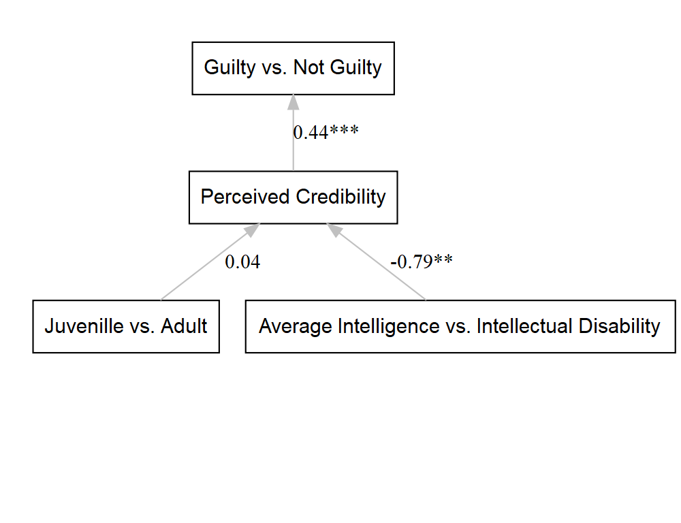

#########################################

#final plotting   
#Original hypothesis was that the two conditions and their interaction would predict how credible the confession was  
#How credible the confession was, in turn would predict if the person voted guilty vs. not guilty   
#If we assume that there is no direct effect of the conditions or interaction on guilt, then model 4   
  
  
labels2.0 = list(guilt.dichot = "Guilty vs. \n Not Guilty", perc = "Perceived Credibility \n of the Confession",   
 juv.rev= "Adult vs. \n Juvenille", dis="Average Intelligence vs. \n Intellectual Disability",  
 interaction_termr="Juvenille x \n Intellectual Disability Interaction")  
  
  
finalplot1<-lavaanPlot(model = fit4,   
 graph_options = list(rankdir = "BT"),  
 labels = labels2.0,  
 node_options = list(shape = "box", fontname = "Helvetica"),  
 edge_options = list(color = "grey"), coefs = TRUE, stars="regress")  
  
finalplot1

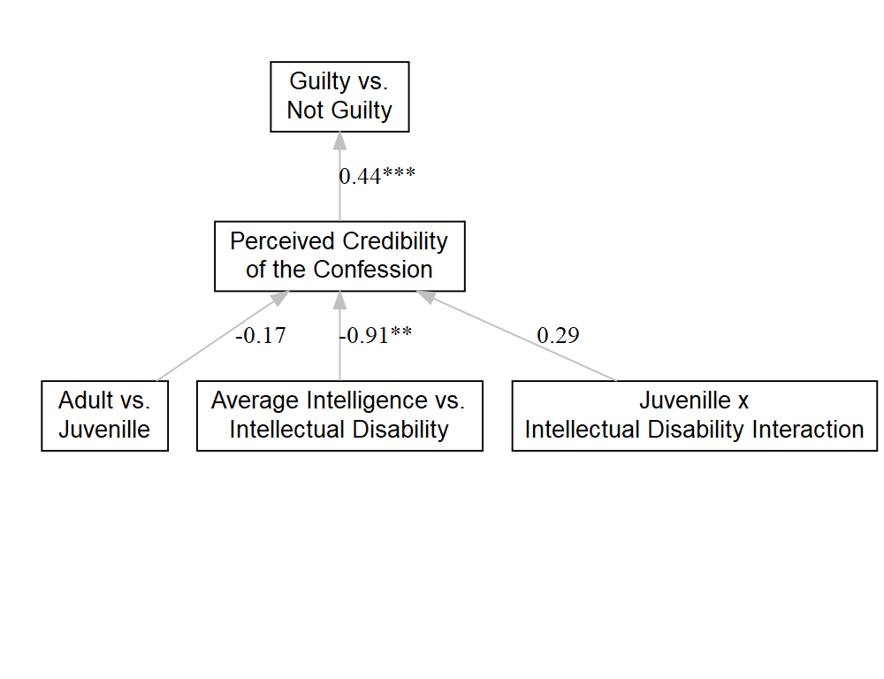

embed_plot_pdf(finalplot1, "Path analysis plot.pdf", width = 2000, height = 2000)

save_png(finalplot1, "Path analysis plot.png", width = 2000, height = 2000)